**The UK Municipal Bonds Agency**

**Establishment of a Local Government Collective Agency for the issue of Local Authority Bonds**

**Report to the Executive Board of the Local Government Association:**

**Review of Outline Business Case and Recommendations for Next Steps**

**March 2014**

**Authors:**

**Aidan Brady Lars Andersson Francis Breedon**

**Lead Advisor Strategic Adviser Strategic Adviser**

**Contents**

**Section Contents Page**

1 Executive Summary 3

2 Public Interest Case 13

3 Local Authority Demand 23

4 Investor Demand, Potential Bond Pricing 34

5 Market Entry Strategy 44

6 Joint & Several Guarantee: Business case 45

7 Joint & Several Guarantee: Protection for guarantors 46

8 Pricing Strategy 53

9 Operating Model and Timeline 55

10 Financial Risks and Mitigants 62

11 Capital Structure 65

12 Governance Structure 67

13 Board of Directors 69

Appendices

1 The journey taken by other agencies 71

2 The broader benefits of a municipal bonds agency 78

3 Outstanding amounts of Local Authority 87 borrowing and investments

4 Additional market background 88

5 Biographies of authors 94

Glossary 96

# Executive Summary

**1.1 Background**

* + 1. Local Authority borrowing in the UK, as of 31 March 2013, amounted to £84.5 billion, of which £63.4 billion was from the Public Work Loans Board, (“PWLB”).
    2. On 20 October 2010, the PWLB began charging a margin over Gilts of 100 basis points on all loans.
    3. In response, in January 2012, the Local Government Association (“LGA”), in partnership with Local Partnerships and the Welsh Local Government Association, published the Outline Business Case for establishing a local government collective agency for issuing Local Authority bonds.
    4. The report identified that such an agency could reduce the funding costs of Local Authorities to 70 to 80 basis points above Gilts vs the PWLB rate of 100 basis points above Gilts.
    5. Subsequently, from 1 November 2012, the PWLB reduced its rate to 80 basis points above Gilts, the Certainty Rate, for those Local Authorities, which could supply details of funding requirements in advance. Approximately 98% of subsequent advances from the PWLB have been at the Certainty Rate.
    6. From 1 November 2013 rates were reduced to 60 basis points for lending in respect of an infrastructure project nominated by a Local Enterprise Partnership (the Project Rate).
    7. In Q4 2013, the Local Government Association re-established the project to review the viability of a local government collective agency, now known as the Municipal Bonds Agency (“the Agency”). In January 2014, the authors of this report were appointed as lead and strategic advisers to perform a review of the original Outline Business Case.
  1. **Scope of Review**
     1. The scope of the review was to reassess the original Outline Business Case, conclude on whether there was a business case for establishing the Agency and make recommendations for strengthening the original model.
     2. The key questions to be answered as part of the review included:
* The Public Interest Case: Is establishing the Agency in the public interest?
* Local Authority Demand: Is there a demand amongst Local Authorities for the Agency and is it in sufficient volume?
* Investor Demand: Is there sufficient investor demand for Agency bonds, and at what price? By how much will ratings impact pricing?
* Market entry strategy: What is the appropriate market entry strategy, for the Agency?
* Timeline and build out: What is an appropriate timeline for the build-out of the Agency and how should it be phased?
  + 1. The following questions should be considered in more detail in later stages of the Agency’s development:
* Regulatory status: the initial review concluded that the Agency was not carrying on a regulated activity. It would be prudent to meet with the financial regulators once the detailed structure has been finalised.
* In addition, it will be necessary to assess in due course the regulatory treatment of the bonds issued and their Bank of England repo eligibility.
* Detailed corporate structure, including tax status: The Agency will require a very simple structure, and there is no reason to adjust the guidance from the Outline Business Case. Further analysis of detailed choices may be necessary as part of the implementation process.
  1. **High level conclusions arising from the review**
     1. **Public Interest Case**
     2. The primary reason put forward for the Agency has typically been to ‘beat the PWLB’ rate.
     3. Whilst this should be achievable, with an appropriate structure, the Agency should aspire to delivering a broader set of benefits, which may prove significantly more material over time.
     4. Estimates of savings versus the PWLB vary and will develop as the Agency matures and volumes expand.
     5. If the Agency achieves the same pricing as Transport for London (“TfL”), the nearest market comparable, then savings should be approximately 5 basis points, and it may be able to achieve an additional ~5 basis points, with a sufficiently compelling relative value proposition.
     6. However, the Agency, has the opportunity to structure itself in such a way as to achieve AAA / Sovereign like ratings, in which case, conservative estimates would put savings at between 5 and 10 basis points on top of the base case.
     7. As the Agency matures, it should expect, with an AAA / Sovereign like rating to achieve pricing closer to Manchester or Cambridge University, delivering savings of 20 to 25 basis points.
     8. Accessing savings at the higher levels is likely to require a Joint & Several Guarantee.
     9. Nevertheless, an obsessive focus on ‘beating the PWLB’ materially undersells the broader benefits the Agency could deliver.
        1. Increased competition / diversification of lending sources: Currently, Local Authorities source 75% of their term borrowings from the PWLB, a source which carries significant political risk; an Agency would materially mitigate this risk and introduce competition to the market for Local Authority borrowing.
        2. Increased Transparency and Monitoring: The PWLB’s process, whilst very efficient, does not carry the normal level of scrutiny lending large sums of money would entail. Experience in other countries has shown that an Agency’s credit processes, aligned with the incentive of lower borrowing costs and the oversight of peers, has strengthened the overall credit worthiness of Local Authorities, much more so than Governments could achieve on their own.
        3. Centre of Expertise: The Agency will be required to build skills at the intersection between capital markets and Local Authority finance. This expertise has been used by other Agencies to facilitate knowledge transfer, conduct research into public sector financing and consider economic factors which will impact Local Authority finances, and therefore their provision of services.
        4. Tailored flexibility: Tailored flexibility will evolve from developing a Centre of Expertise. The most striking thing about Local Authority finances is the volume of predominantly short dated assets (£37 billion) and long dated liabilities (£84 billion), see Appendix 3, with consequent embedded maturity risk and costs.
        5. These assets and liabilities are not evenly spread, i.e. some Authorities will have assets whilst others will have debt, nevertheless, approximately £26 billion of assets are held by individual Local Authorities with offsetting long dated liabilities
        6. Whilst not directly part of the Agency’s mandate, nor this review, there exists the opportunity to help reduce these volumes.
        7. Initially this may take the form of advisory services, but in due course could be expected to include facilitating increased intra-Local Authority lending, potentially leveraging Bond programmes, and introducing tailored flexibility to lending programmes.
  2. **Local Authority demand**
     1. As part of this exercise, we reviewed Local Authority demand by reference to PWLB refinancing, bank lending refinancing and new lending.
        1. PWLB refinancing: PWLB lending of £63 billion to Local Authorities matures at the rate (conservatively) of £1.7 billion each year, much of which will require refinancing.
        2. Bank financing: Bank financing, of over £7 billion, predominantly in the form of Lender Option Borrower Option loans, is likely to become more expensive as margin pressures on banks increase.
        3. New Lending: Local Authorities will come under increasing pressure for capital spending as the need for overdue expenditure on highways and infrastructure becomes pressing and to deal with trends in population demographics.
        4. These macro indicators would suggest that there is a significant ongoing demand for Local Authority Borrowing.
     2. Nevertheless, we conducted our own survey of 132 English councils.
        1. We received over 50 responses, with 4 having no borrowing requirements in the next 3 years.
        2. On the remaining responses, all but 4 i.e. >90%, with borrowing requirements of ~£5 billion in the next 3 years would consider using the Agency, with no significant impediments to so doing.
        3. Clearly, this survey is indicative, with issues of flexibility and pricing requiring resolution. Nonetheless, it is a strong indicator of pent up demand for an alternative to the PWLB.
  3. **Investor demand and likely bond pricing**
     1. We met with 6 of the top 10 leading Sterling syndicate banks.
     2. The general sense was that there was likely to be significant demand for the Agency’s bonds.
     3. Pricing of the bonds is likely to be primarily driven by market pricing of comparable bonds, the most comparable being TfL. At TfL’s pricing, the Agency could deliver savings to Local Authority borrowers of approximately 5 basis points.
     4. If the Agency wants to achieve better than TfL pricing, it will need to demonstrate a significant relative value comparison.
     5. The way to achieve this is through a better credit rating that is achieved in an appropriate manner, i.e. significant and observable credit enhancement, and to match the quality of execution.
     6. TfL is one notch off a Sovereign rating; accordingly the Agency should aim for AAA / Sovereign like rating. The challenge in achieving an AAA / Sovereign like rating is not to be underestimated and will require significant credit enhancement.
     7. The risk of not achieving AAA / Sovereign like rating will be materially mitigated with significant first loss / risk capital, (between 3 and 5%, which can be used for liquidity purposes), adequate liquidity, a Joint and Several Guarantee from borrowers and a suitably diversified portfolio of borrowers, which meet the requirements of a rigorous credit process.
     8. Achieving AAA / Sovereign like credit ratings, with a Joint & Several Guarantee should enable the Agency to deliver significant savings to borrowers. Estimates vary between 5 to 10 basis points, (conservative), to 20+ basis points over that achievable by TfL pricing.
     9. In any event, a number of other factors will influence pricing. The Agency is likely to suffer a new issue premium and a liquidity premium, reflecting the fact that the Agency will be a new issuer to the market and will not have covered the maturity profile / built a yield curve.
     10. These premiums should evaporate within 1 to 2 years, but will impact the level of savings available to early borrowers.
     11. Another key concern will be the ability to issue bonds in benchmark sizes, i.e. £250 to £300 million. Failure to do so will add up to 20 basis points to the bond pricing, and eliminate any potential savings for early issuances.
     12. An additional point for consideration is the level of complexity in the bond structure. Investors have limited resources for reviewing new bond issuances, so complexity becomes a deciding factor.
     13. With a Joint and Several Guarantee, the level of complexity reduces. Bonds can be listed on the London Stock Exchange, taking advantage of the listing exemptions for Local Authorities, otherwise overseas exchanges may need to be considered.
  4. **Market entry strategy**
     1. The foregoing should inform any market entry strategy.
     2. Initial bonds will price higher, so there is a natural incentive to manage the bond programme accordingly. Nonetheless, the Agency should aim to deliver savings to early stage borrowers, so they should still see benefits.
     3. The Agency should develop its profile over a one to 2 year period, issuing bonds in benchmark sizes, whose timing corresponds to peaks in Local Authority borrowing.
     4. Timing peaks in March / April, so the Agency should target a first bond in March / April 2015. The next peak occurs in September / October, which, accordingly, should be the anticipate timing of the next bond.
     5. In subsequent issuances, the Agency should aim to cover more of the maturity profile, and accordingly, target £500 million plus of issuance in March / April 2016, in appropriate maturities.
     6. Two factors will influence the choices for the maturity of the first bond: Market preference and Local Authority demand. During the lead up to the first Bond issuance, these factors would need to be reconciled.
     7. Notwithstanding the demand identified as part of the survey, the Agency would need to have visibility on issuing approximately £750 million per annum in the early years. We would estimate that this represents approximately 25% market share of Local Authority borrowing.
  5. **Joint & Several Guarantee: Business Case**
     1. With a Joint and Several Guarantee, Local Authorities should have a reasonable expectation that they could reduce their borrowing costs by 20 to 25 basis points, versus the PWLB.
     2. On a £100m loan, this equates to savings of £200 to £250 thousand, per annum, or £6.0 to £7.5 million over the life of a 30 year loan.

* 1. **Joint & Several Guarantee: Protection for Local Authorities**
     1. Local Authorities will have concerns over issuing a Joint & Several Guarantee.
     2. There are significant protections within the statutory framework, which governs Local Authority finances e.g. the Prudential Code, implied Government support, which is somewhat evidenced by the operations of the PWLB, etc.
     3. English law contains a number of protections, such as a right of indemnity, that help ensure that guarantors can recover payments they make under the guarantee.
     4. Nevertheless, it would be appropriate to underpin a Joint and Several Guarantee with a Right of Recourse, or equivalent, which ensure that in the event of any loss, the amount in default is distributed proportionately amongst those providing the Guarantee (i.e. the borrowers from the Agency).
     5. Even in the event a Guarantee is called, it should be noted that creditors will still have access to the High Court process, that enables a High Court appointed administrator to ‘take control’ of certain aspects of a Local Authority’s finances, which in this scenario would be done under the auspices of the Agency.
     6. We have sought legal advice from leading counsel, which is unequivocal that such a Joint & Several Guarantee would be within vires, for English councils, available under the General Power of Competence created by the Localism Act.
  2. **Pricing strategy**
     1. The model proposed envisages a simple and transparent pricing mechanism is implemented, with 10 basis points added to the interest margin for borrowers to cover the Agency’s costs. Variable pricing, based on borrower creditworthiness, was reviewed and not considered appropriate
     2. The Board of the Agency should review the Agency’s pricing and pricing strategy on a regular basis

* 1. **Operating Capital, Model and Timeline**
     1. The Agency and its sponsors should endeavour to maintain momentum and issue an initial bond in March / April 2015, i.e. in 12 Months.
     2. To achieve this timeline the Agency will require a mobilisation phase, to start immediately after the decision to proceed.
     3. The objectives of the mobilisation phase include: establishing the corporate structure and capitalisation, hiring key permanent staff, developing the policies, procedures and process necessary to run the Agency, identifying outsource partners and other 3rd party providers and locking down on the initial set of borrowers.
     4. It is estimated the mobilisation phase will cost £800k, of which approximately half will be related to the corporate entity, including structuring.
     5. The Agency, itself, should anticipate a phased development, which reflects upon the likely volume of transactions, e.g. in Year 1, the Agency should aim to issue 2 bonds with approximately 30 to 40 borrowers.
     6. The Agency will operate on a matched funding basis in the early years, i.e. Local Authority lending will match bond maturity, interest and repayment profiles.
     7. Accordingly, headcount should be built out cautiously, with no more than 6 staff required in the first year of operations. The forecast assumes incremental headcount to deal with volume increases.
     8. Nonetheless, the Agency is likely to have to absorb significant cost in the early years, e.g. the set up legal costs for a Euro Medium Term Note (‘EMTN’) programme. The Agency is not anticipated to break even until it has reached ~£2 billion in bond issuance, which is not likely to happen until year 3, post launch.
     9. Accordingly, the Agency is expected to spend between £3.5 and £4 million of its capital prior to breakeven. As the Agency moves into profit, this expense would effectively be recovered
     10. Once breakeven is achieved, the platform should be scalable, without commensurate increases in costs, and with long term visibility over revenues.
     11. Some cost estimates have been included in the financials to deal with possible business development, particularly a Commercial Paper Programme
     12. Any business development should be subject to an appropriate business case at that point in time, so any estimates should be viewed as indicative.
  2. **Key Risks and Related Mitigants**
     1. There are 5 key risks identified in the model:
  + It may not be possible to raise the required level of operating capital,
  + Local Authority demand for the Agency may not materialise,
  + Market pricing, for any bond issuance, may not be attractive,
  + The PWLB may reduce the margin over Gilts sufficiently to render the Agency an unattractive choice for Local Authority borrowing, and
  + The Agency may not be able to attract personnel of sufficient calibre on a timely basis
    1. Each of these is dealt with in more detail in Section 9, nevertheless, it worth sizing the resources at risk in the executive summary. (Resource at risk excludes sunk costs.)
    2. The ability to raise operating capital will become clear during the mobilisation phase. If it is not possible to raise a sufficient equity, the corporate structuring related costs are not required, so the resource at risk is £400 thousand or less.
    3. The level of Local Authority demand should be kept under constant review, particularly in the mobilisation phase. If the level of demand isn’t sufficient, during the mobilisation phase, then the project should consider aborting. Nevertheless, resources at risk, up to January 2016 are estimated between £400 thousand, if abort happens before the corporate structure established, to £2 million, being mobilisation costs plus one year’s operating expense.
    4. If market pricing proves unattractive, it is likely that this will evolve through the syndicate process and, therefore, that legal and ratings fees will have to be added to the preceding, as the EMTN programme will have been set up, ratings sought etc., so the resource at risk moves to ~£3.0 million.
    5. The PWLB may reduce its rates, rendering any bond issuance unattractive. Given the impossibility of predicting when that may happen, it is difficult to estimate the level of resource put at risk, other than where it might match the above in terms of timing. (If it occurs after a bond has been issued, trail fees on the bond, aligned with cost reduction, may mitigate the risk.)
    6. The Agency may not be able to attract staff: On balance, this is viewed as unlikely and availability of interim staff may mitigate. Nevertheless, this may be a risk to the cost estimates
  1. **Capital Structure**
     1. Operating Capital is required to meet on-going expenses: It is recommended that the Agency raise £8 to 10 million in common equity.
        1. The number, of £8 to £10 million is based on the estimated net costs to break even, of £3.5 to £4 million, with a conservative buffer added to cover cost overruns / timing delays.
        2. To the extent that such capital may not be required prior to breakeven, it may be used for business development purposes, subject to business case approval.
        3. In order to compensate early shareholders, it is further recommended that a dividend policy be implemented, providing an economic level of return. This should be reviewed in detail as part of the capital raising process
     2. Risk Capital is required to provide first loss protection in the event of a borrower default. It is recommended that the Agency structure risk capital, in the amount of 3 to 5%, as holdbacks from Local Authority borrows.
        1. Such an approach should add 3 basis points, or less, to the cost of loans, and is materially cheaper than raising subordinated risk capital separately.
        2. In addition, it removes the risk of mismatch between the level of capital required, based on Local Authority loans, and subordinated Capital available, which is raised independently.
  2. **Governance structure**
     1. During the mobilisation phase, control of the project is paramount.
     2. Accordingly, it recommended that the project sponsors, the LGA, retain control of the project.
     3. The project should be lead by a Project Board, with 5 to 7 representatives, including Local Authority Finance Directors, or their equivalent, and LGA executives.
     4. The existing CFO and Political Leaders groups should retain their current advisory roles, which have proved very helpful.
     5. Whilst the Board of the Agency (“Board”) shall be appointed during the mobilisation phase, it shall not become established until formal launch. This Board may act as a shadow Board during mobilisation and should expect to be consulted accordingly.
     6. Post launch, the Board should take control of the Agency. (Launch is defined as the point in time, which the Agency begins making commitments, for example appointing ratings agencies or syndicate banks, and should be decided by the Project Board in consultation with the Board of Directors.)
     7. The Board itself should consist of up to 7 Non-Executives, including 3 elected Local Authority representatives, 2 Local Authority Finance Directors and 2 ‘experts’, one each from capital markets and risk backgrounds.
     8. Candidates for the Board should be vetted by a Nominations Committee, with candidates for election undergoing a screening process, and Finance Directors / Experts being recommended by the Nominations Committee.
     9. During the mobilisation phase, consideration needs to be given to appropriate safeguards, to ensure that the Agency stays true to its original mandate.

# Public Interest Case

* 1. The key conclusions emerging from a review of the Public Interest Case are as follows:
     1. Potential savings to Local Authorities
  + The Agency should be able to reduce the cost of borrowing for fixed term loans. The level of savings will depend upon ratings / structure.
  + Savings should increase as the bond issuance programme matures and Agency costs are spread over a larger volume of loans.
  + Potential additional savings from a Commercial Paper Programme.
  + Early repayment penalties should be lower than the PWLB’s.
    1. Increased competition and diversity of funding sources
* Local Authorities rely on the PWLB for 75% of term borrowing.
* Other sources are unlikely to displace the PWLB’s position.
* The risk exists that the PWLB may change lending practices / pricing.
* The establishment of an Agency will materially mitigate the risk, inherent in over-reliance on a single funding source and introduce increased competition.
  + 1. Increased transparency and monitoring
* An Agency would place increased scrutiny on Local Authority finances, both by peers and the financial markets.
* Peer pressure has proven most effective, in other countries, in raising Local Authority creditworthiness.
* The Agency would incentivise Local Authorities to improve their credit worthiness in order to access funding at lower cost.
  + 1. Centre of Expertise
* The Agency will be a centre of expertise, intersecting between capital markets and Local Authority financing.
* The Agency will have the opportunities to:
  + Support research in Local Government financing questions.
  + Transfer knowledge via regular publications and seminars.
  + Consider issues of primary economic and financial importance to Local Authorities.
    1. Tailored flexibility – a natural progression from a Centre of Expertise
* Local Authorities have £84 billion in Long Dated Liabilities and £37 billion in short dated assets, (£26 billion of which is in Authorities with offsetting assets and liabilities).
* Local Authorities bear the risks, and financing costs, inherent in this maturity mismatch.
* Over time, the Agency could develop, advisory and tailored lending services, and potentially facilitate intra-Local Authority lending.
* Such arrangements could enable a reduction in the volume of maturity mismatch, currently managed within individual Local Authorities.
  1. **General Background**
     1. Currently the vast majority of Local Authority finance, approximately 75%, comes directly from Central Government through the PWLB.
     2. Given the objectives and expertise of Central Government, this results in lending to authorities being guided by macroeconomic considerations (such as the overall level of Local Authority borrowing and its overall cost of capital) rather than microeconomic ones, (creditworthiness of individual borrowers, economic value of individual projects etc.).
     3. This framework is in stark contrast to private sector lending where loans and borrowers are assessed on an individual basis first and foremost. It is also problematic for two key reasons.
        1. Individual Local Authority borrowing is subject to significant regulatory risk where the amounts available and the terms under which it is available vary for macroeconomic policy reasons that are largely unpredictable and outside Local Authority control.

* + - 1. There is little oversight by the lender of individual loans so there are few controls in place to identify weak credits or poor financial management and processes.

* + 1. Given the relationship between Central and Local Government and the importance of localism, it is hard to think of changes to the current PWLB arrangements that would create adequate oversight without creating, or being seen to create, Central Government interference in local affairs.
    2. Thus this report proposes arrangements where regulatory risk is mitigated and individual oversight is improved by allowing Local Authorities to borrow from financial markets through their own debt agency.
    3. In particular it proposes frameworks where Local Authorities are financially exposed to one another – to some degree. This creates strong incentives for the financial expertise that exists in this sector to be used to monitor and improve the performance of weaker borrowers.
    4. This report also propose that the Agency helps to co-ordinate this expertise and improve both debt and treasury management of Local Authorities to the benefit of the wider economy.
  1. **Potential savings to Local Authorities**
     1. **Term Lending**
        1. The original public interest case was largely founded on the premise that issuing bonds through a collective agency could reduce funding costs to local authorities.
        2. The price at which Bonds can be issued, and by default the interest rates at which loans can be granted to Local Authorities, will be driven by market pricing at the time of issue.
        3. Nevertheless, there now exists increased market evidence, which can help guide considerations in this respect. The more interesting to note are Transport for London (TfL) and Manchester and Cambridge Universities and Network Rail.
* TfL, rated Aa2 / AA+ / AA, has been running a very successful Bond programme since July 2012. Their first bonds issued at 98 basis points over Gilts, which reduced to 58 basis points over Gilts in September 2013[1].
* Manchester University Aa1 and Cambridge University, rated AAA, have both issued Bonds at 60 basis points over Gilts.
* Secondary market trading has seen TfL priced at 50 basis points over Gilts and Manchester and Cambridge Universities trading as low as 37 to 45 basis points over Gilts.
* Network Rail, which benefits from an explicit Government guarantee, issues and prices around 30 basis points above Gilts.
  + - 1. It is important to note that the first issue of the Agency is likely to price higher than it should expect once it has established track record. (This ‘new issue premium’ is somewhat mitigated, at this stage, as other European agencies have established municipal bond agencies as an asset class.)
      2. In addition, any bonds will be penalised, in terms of pricing, based on complexity, failure to issue benchmark sizes i.e. £250m to £300m and rating. Section 4 on Investor Demand contains detail on more comparators.
      3. In effect, though, these prices effectively set the boundaries of where the Agency is likely to price, i.e. somewhere between 58 and 30 basis points over Gilts, once pricing has become normalised and the Agency overcomes the new issuer effect.
      4. Where the Agency’s bonds ultimately price will be determined by its relative attractiveness versus other issuers and market pricing.
      5. Prima facie, the most comparable issuer currently in the market is TfL, which priced at 58 basis points over Gilts1. At 58 basis points over Gilts, the Agency will be able to deliver savings of approximately 5 basis points.
      6. With appropriate credit enhancements and a sufficiently robust structure, however, the Agency should aim to attract a higher rating than TfL. These credit enhancements are discussed in more detail in Section 4. Nevertheless, options considered include the following:
* An appropriate credit and liquidity risk process
* Risk Capital
* A Joint and Several Guarantee
* Diversification of exposures

Taken in combination and appropriately executed, these enhancements should enable the Agency to target an AAA / Sovereign like rating.

* + - 1. Were the Agency to attract such a rating and with an appropriate structure and execution, it could expect, over time, better pricing than TfL. Discussions with banks have placed estimates of the resultant savings varying from 5 to 10 basis points at the low end to Network Rail like pricing at the high end i.e. 20+ basis points below TfL.

* + - 1. Accordingly, the potential savings from the Agency to Local Authority borrowers could increase to approximately 20 to 25 basis points.
      2. These numbers increase as the Agency matures and is able to spread its operating costs over a larger volume of loans. The starting assumption is that operating costs will add 10 basis points to loan cost in the early years as the portfolio of lending is built up. It should be possible to reduce this in later years.
    1. **Commercial Paper Programme**
       1. Local Authorities currently lend £2.9 billion to each other, on a short-term basis. Much of this will be through brokers, who will charge a fee. Other than intra-Local Authority lending, volumes of short-term borrowings appear to be quite modest, at £0.5 billion.
       2. In addition to supplying term financing to Local Authorities, the Agency should consider, in due course, implementing a Commercial Paper Programme. Such a programme would deal with short term borrowing requirements, typically in maturities of 3 months to 1 year. Individual authorities, which have implemented such programmes, have seen their short dated funding costs reduce below base rates, to 40 basis points, or less.
       3. Incremental products and services should be subjected to appropriate analysis and a separate business case developed for approval, at the appropriate time.
    2. **Early repayment penalties**
       1. Early repayment penalties are of significant concern to Local Authorities.

* + - 1. The PWLB Circular 155 on Lending Arrangements notes: The terms for accepting an early repayment are designed to protect the National Loans Fund. The total amount payable in order to redeem a debt is the present value (PV) of the remaining payments of principal and interest, calculated on normal actuarial principles. PWLB Technical Note, issued December 2012, notes: For early repayment ratesthe minimum par yield for each average life band is calculated. Next, a margin is subtracted. For PWLB and NLF loans this margin is currently 11 basis points at all maturities.
      2. The Agency would be required to adopt a similar principle to the PWLB, with respect to protecting the Agency. However, the Agency’s application of that principle should result in lower penalties.
      3. In the event of early repayment, the Agency would have to either:
* Retire the debt; repurchase bonds issued in the secondary market,
* Replace the asset; purchase sufficient Gilts of an equivalent maturity to the loan being repaid, in order to fund the repayment of the related bond.
  + - 1. The main variable, which would impact repayment penalties, is the movement in Gilt yields, from the point in time at which the loan was made to the point in time in which it is repaid. On this variable, there should be no difference between the PWLB and the Agency.
      2. However, the Agency’s repayment rates should be lower, simply because it will charge a lower margin over Gilts for Local Authority lending, and, therefore, the volume of future repayments of principal and interest will be lower.
      3. In addition, it will not adjust discount rates and rely purely on market pricing to determine repayment penalties. The margin subtracted by the PWLB from the discount rate, will have the effect of increasing the amount repayable.
      4. Nevertheless, potentially offsetting these will be the secondary market performance of any bonds issued, which may make retiring the debt either more or less expensive, depending upon whether the bond’s margin over Gilts has narrowed or widened. (The margin over Gilts is expected to narrow, making retiring the debt more expensive.) In addition, it may prove difficult to repurchase bonds in the desired quantities or at a price, which is attractive. This should not impact the cost of replacing the asset i.e. buying Gilts.
      5. As the Agency will have to use market pricing in order to calculate early repayment penalties, Local Authority borrowers who wish to repay early will not be able to have the amount of the repayment penalty communicated immediately, as they can with the PWLB. In addition, there may be a degree of risk in the amount until the required underlying transactions have been executed. Nevertheless, this process should deliver savings to Local Authorities.
      6. Whereas the PWLB will only allow transfer of loans in the event of Local Government reorganisation, the Agency should be relaxed about the transfer of loans, subject to the transferee meeting the Agency’s credit requirements, introducing the opportunity to reduce costs further.
  1. **Increased competition amongst / diversification of funding sources**
     1. A high level breakdown of Long Term UK Local Authority Borrowing, as of March 2013, is as follows:
* PWLB £63.4 billion 75%
* Banks and other financial institutions £11.4 billion 13%
* Public Markets, Securities Issued £ 4.4 billion 5%
* Other £ 4.8 billion 7%

(In addition, Local Authorities lend each other approximately £0.9 billion, long term.)

* + 1. Its relatively competitive pricing and flexibility i.e. the ability to draw down loans at very short notice, in varying maturities, drive the PWLB’s dominant market share in Local Authority lending. Nevertheless, it does carry all of the risks of a monopoly supplier.
    2. Local Authorities do have other borrowing options available, but, realistically, none of them remotely threaten the PWLB’s dominant position.
* Bond issuance: the ability to issue regularly in benchmark sizes is only available to a handful of authorities.
* Only the Greater London Authority and TfL have issued Bonds in the last few years, no councils.
* Bank lending: Likely to come under increasing pricing pressure as CRD IV is implemented.
* Other sources may become opportunistically available to Local Authorities, such as borrowing from the EIB.
  + 1. Should Local Government be concerned by the PWLB’s dominant market position?
    2. Over-reliance on the PWLB carries significant regulatory risk, insofar as the rate charged will be influenced by political considerations. The PWLB has a long history of changing the amount, accepted counterparties, and the rate at which it lends to Local authorities. For example, in 1955 the PWLB suddenly switched from an open access policy to become only a lender of last resort requiring a rapid and costly change in local authority borrowing practices.
    3. Generally, observers suggest that most of these changes have taken place as means of controlling overall Local Authority borrowing in line with Central Government objectives, rather than an underlying wish to alter the operation of the PWLB[2].
    4. These sudden and largely unexpected changes in PWLB lending policy have imposed significant costs on Local Authorities and has, for example, required them to keep open other borrowing channels at some cost to themselves in order to protect themselves from sudden funding shortages.
    5. This is illustrated by the following brief history of PWLB lending policy

|  |  |  |
| --- | --- | --- |
| **Period** | **PWLB Policy** | **Suggested reason for Policy** |
| 1919-1939 | Loans only to smaller authorities (rateable value less than £200 thousand) | Restricted funds available to PWLB |
| 1945-1952 | Open access to PWLB, but authorities prohibited from borrowing from other sources | To control overall borrowing in a period of large capital demand |
| 1952-1955 | Open access to PWLB and other sources |  |
| 1955-1963 | PWLB lender of last resort only | Large-scale PWLB borrowing seen as interfering with government monetary and credit policy |
| 1964-1982 | Access to a quota of longer term (10 year) loans in return for a significant cut in short term borrowing (LOLR still available at a higher interest rate) | Concern over high level of short term market borrowing by Local Authorities |
| 1982- | Quota raised to point where effectively all borrowing could be undertaken through PWLB quota. Minimum maturity reduced to 3 years | Central government concern over reduced capital expenditure during period of revenue restrictions |

* + 1. As noted in each Circular, published by the PWLB, detailed lending arrangements, “HM Treasury reserves the right to alter formulae, margins and or other parameters used in the calculation of the rates for PWLB fixed loans and variable rate loans, exceptionally without notice.”
    2. Local Authorities in the UK, should collectively and individually, take a view on whether these risks are acceptable, as part of their determination of whether or not to establish an Agency.
    3. A successfully established agency, with a significant footprint amongst Local Authorities and Investors, would significantly mitigate the risks.
  1. **Increased transparency and monitoring** 
     1. Whilst the PWLB is generally a quick and efficient source of finance for Local Authorities, it is opaque and is undertaken without the normal level of scrutiny that such lending would attract.
     2. In contrast, the Agency would require a rigorous and transparent credit process. Such a credit process would both underpin the Agency’s credit rating and support the ability of Local Authorities to give Joint and Several Guarantees.
     3. The Prudential Code and statutory underpinnings of Local Authority finances, provide a high level of comfort about their overall state. Nevertheless, it would be wrong to be complacent. There is a level of inherent risk, which the Agency could help mitigate.
     4. In an interview in 2012, Lars Andersen, who founded Kommuninvest, the Swedish Local Government Agency, noted the following:

“A collective agency for the local public sector, owned by the local public sector, puts a great responsibility on that sector… to improve and maintain a good creditworthiness. This can be done by only accepting local authorities with good financial order into the agency and to survey the situation of the existing members in the agency. *This puts a substantial peer pressure on local authorities, which has proven to be more effective than central government supervision.* It will create a situation where the non-members can see that members are getting a stable access to cost-efficient borrowing and hence the non-members will strive to improve their financial situation so that they can be members.”

* + 1. Accordingly, the creation of the Agency would significantly increase the transparency of Local authority borrowing and create greater scrutiny of the borrowing both by Local authorities of each other and by financial markets. (Since the structure of the Agency will result in the borrowing costs of each authority being related to the performance of all the other authorities that use the Agency, there will be greater peer scrutiny.)
    2. In the UK, there are over 400 entities, including, Councils, Fire Authorities and Police Authorities, whose levels of borrowing and investments are tracked by CLG. Credit hurdles would, initially, prevent some from being able to access borrowing from the Agency. Nevertheless, the establishment of the Agency would begin to set benchmarks for credit strength, and implement significant incentives for the weaker Local Authorities to rise to the standards of the highest.
    3. Local Authorities, themselves, would welcome greater transparency and scrutiny of their borrowings as a means of ensuring best practice and best value for money for Council Tax payers.
  1. **Centre of Expertise**
     1. In addition to Loans of £84 billion, the UK Local Government sector also has £37 billion in Investments, (including £1.6 billion in Gilts), of which £26 billion of investments, is held in Local Authorities with offsetting liabilities
     2. Whilst the focus of this exercise is predominantly on the 80 basis points margin over Gilts, charged by the PWLB, Local Authority gross financing costs, and net after investment income, are clearly more material. Whilst beyond the scope of this review, the numbers involved are likely to be substantial, with gross estimated financing costs in the region of £3 to £4 billion and investment income, somewhat less, at around £0.5 billion.
     3. Collectively, Local Authorities would have a similar profile to a relatively complex financial institution, in terms of the risks being managed, ranging from credit risk, investment risk, maturity risk, interest rate risk etc.
     4. To help manage these risks, individual local authorities employ professional finance and treasury teams, in addition to being able to hire consultants who specialise in this sector.
     5. Nevertheless, there are potentially significant benefits to the sector from being able to leverage a centre of expertise, whose primary raison d’etre was to help manage financing risk, and mitigate its costs, for Local Authorities.
     6. Some initiatives are already in place in this regard, for example collective investment vehicles for council pension funds.
     7. It is worth noting what Kommuninvest does in this regard:
* **Research**: Kommuninvest supports research in matters related to local government financing and related questions. Universities and other research institutions can once a year apply for grants to specific projects. The result of the supported research is communicated to Swedish local authorities.
* **Transfer of Knowledge**: Kommuninvest has taken on a role to inform the local authorities and to “teach” them about financial markets, financial instruments and risk management. To support this activity, Kommuninvest publishes magazines and newsletters, in addition to running seminars.
* **Governance Structure**: Kommuninvest’s Credit Research & Financial Committee:
  + Considers issues of primary economic and financial importance to the municipal sector.
  + Deals with issues regarding future assessments relating to the financial position of the municipal sector, and national economic developments
    1. Whilst, one could argue that a plethora of initiatives and organisations already occupy this space, it is not clear that a single independent organisation has a mandate to specifically address its challenges.
    2. The Agency will have to build the relevant expertise to support its core activities, in any event. The ability to, at a minimum, add an authoritative voice to the debate and build appropriate solutions in due course, could potentially add significant value.
  1. **Tailored flexibility, a natural progression from Centre of Expertise**
     1. A memorandum, in 2009, from the PWLB to the Communities and Local Government Select Committee noted “The Board's function is to provide capital finance to local authorities, not to be an active treasury management counterparty.”
     2. Whilst the memo was in response to the introduction of early repayment penalties, this sentence neatly encapsulates what should be a fundamental philosophical difference between a Local Authority controlled Municipal Bonds Agency and the PWLB.
     3. The PWLB provides a very efficient service to UK Local Authorities, but its role should be viewed as that of a third party service provider, with its own mandate and priorities.
     4. In contrast, the Agency could over time adopt the role of “active treasury management counterparty”.
     5. What does this actually mean?
     6. What is striking about Local Authority Balance Sheets Is the mismatch between the predominantly long dated liabilities and, equally, predominantly short dated liquid assets. Some of those assets will be earmarked for repayment of long dated liabilities, yet the respective interest rates are likely to bear no comparison.
     7. In effect, the risks arising from maturity mismatches sit entirely within Local Authorities and their mitigation will depend upon the effectiveness of their treasury and finance functions.
     8. The Agency should be in a position to provide advisory support to treasuries and should aim to help intermediate longer-term intra Local Authority lending, potentially leveraging bond programmes.
     9. As the Agency develops, it will want, and Local Authorities will demand, that it put in place more flexible borrowing arrangements, for example, to allow for loans with an annual repayment profile or a repayment profile linked with expected income flows. (The Agency is unlikely ever to be able to compete, and nor should it want to, with the PWLB, in terms of being able to provide loans at 48 hours’ notice at varying maturities, volumes etc.)
     10. The impact of this on the Agency is that it will, in due course. need more sophisticated hedging strategies and, potentially, implement sinking funds where there are mismatches between bond and loan maturities.
     11. This will require a significant upgrade in both IT and personnel, as the Agency develops appropriate treasury management practices. This only becomes possible when the Agency has covered more of the maturity profile and developed a broader client base, i.e. to justify the underlying investment and to reduce individual transaction costs, the Agency would need a flow of transactions.
     12. This would be a natural progression for the Agency and one, which other Agencies have already undergone.
     13. However, over time, the potential for Local Authority financing becomes transformative as management of maturity mismatches can increasingly be absorbed within the Agency.

# Local Authority Demand

5.1 The key conclusions emerging from a review of Local Authority Demand are as follows:

* + 1. Level and sources of debt
  + The PWLB is the lender of choice for most Local Authorities, with 75% of total lending, but there are also significant levels of Bank Financing, at 14%, including Lender Option, Borrower Option (LOBO) type loans.
  + Local Authorities can only borrow for capital programmes, and are generally financially strong.
  + A review of high level statistics on levels of Local Authority borrowing versus assets, would suggest that a significant number could borrow from the Agency.
  + As Agency pricing should be lower than the PWLB, for term lending, it is likely that a significant number of Local Authorities would find it attractive.
    1. Future Appetite for the Agency
* Refinancing PWLB Debt
  + The PWLB loan maturity profile, would suggest that up to £1.7 billion of borrowing would need to be repaid or refinanced annually.
  + Some Local Authorities are choosing to repay debt, but pressures on finances would suggest that significant volumes of refinancing are required.
* Refinancing Bank Debt
  + Bank lending may be refinanced, particularly if Bank margins increase.
  + (LOBOs account for over £7Bio of Local Authority borrowing and may be subject to interest rate rises as rates go up.)
* New Debt
* New debt is likely to be required for
  + Highways and infrastructure projects, and
  + House building and as a result of Demographic trends.
    1. Immediate demand for the Agency
* The LGA surveyed 132 English councils via email to ascertain their borrowing requirements. The headline details are:
* 50 responses identifying requirements for ~£5 billion of refinancing and borrowing over the coming three years.
* Only three had “no interest” and four had no borrowing needs.
* No potential borrowers have a significant barrier to using the Agency, other than amending treasury strategies.
  + 1. Estimates of aggregate demand
* Estimates of aggregate demand are not generally available, nevertheless, based upon a review of the above, it is likely that annual Local Authority borrowing over the next 3 years will be in the range of £3 to 5 billion annually.
* The business case is based upon achieving a 25% market share of the lower estimate of annual borrowing requirement.

# Level and Sources of Debt

# Local Authorities’ debt totals £84.2 billion, of which £83.7 billion is “long term”. As set out in the chart below, 75 per cent is owed to the PWLB, 14 per cent to banks and financial institutions and only 5 per cent to the capital markets. “Other sources” comprise a wide variety of lenders such as the Government, other local authorities, households and companies.[3]



* + 1. Despite changes to the PWLB rates, discussed elsewhere in this report, most authorities have continued to treat the PWLB as the lender of first resort because obtaining a loan from the PWLB is so easy and the maturity of the loans on offer is so flexible.
    2. However, the changes prompted some authorities to make greater use of bank loans. As can be seen, the relatively high costs of undertaking a capital markets transaction and the fact that few local authorities have sufficient borrowing needs to justify those costs has severely limited funding via the capital markets.
    3. There is wide variation in the levels of local authority indebtedness. As local authorities can only borrow for capital purposes, a crude measure is the ratio of borrowing to assets as shown in 3.2.5. Many district councils have transferred their housing stock to other providers and therefore have limited capital investment needs and low levels of debt.
    4. **Long Term Borrowing as a Proportion of Assets**[4]



# Although the Agency’s internal credit processes and market discipline are likely to curtail access to the Agency where a local authority has high debt levels, it is clear that there would remain a significant number of local authorities that could be eligible to borrow via the Agency.

# Furthermore, the reliance on the PWLB demonstrates that there should be a significant opportunity for the Agency to diversify local authority sources of funding given that that the PWLB should prove more expensive than the Agency once the Agency is established.

# Future Appetite for the Agency

# Refinancing PWLB Debt

# As it matures, debt has to be either repaid or refinanced. Analysis of recent PWLB loans suggests that the average maturity of loans is approximately 19 years.[5] Even if a conservative view of the maturity profile is adopted, the minimum level of maturing PWLB debt each year would be at least £1.7 billion. In itself, even if only 50 per cent refinanced each year via the Agency, this would be sufficient to enable the Agency to become self-sufficient within three years.

# PWLB data shows that the amount of debt maturing each year is greater than £1.7 billion. As shown below, setting aside 2011-12 when HRA self-financing increased local authority debt by around £8.9 billion, even in the face of the economic downturn and severe cuts to funding, Local Authorities increased PWLB debt by £3.7 billion over the past six years. The decision by some authorities to repay debt does not appear to have had a significant effect on the overall level of borrowing.

# 2007-8 to 2012-13 Local Authority PWLB Advances and Repayments



* + - 1. It is increasingly unlikely that many authorities will choose to pay down debt rather than refinance, given the pressures they face. A key area where it had been assumed that debt would be paid down is the Housing Revenue Account (HRA).
      2. Government material published in support of HRA self-financing suggested that the settlement would allow Local Authorities to pay off debt over time. However, this is increasingly unlikely:
* Most local authorities are facing a housing shortage and temporary accommodation is costly to provide and a drain on the Council Tax.[6] Many are seeking to build new homes, which will utilise funds that could be used to pay down debt.
* HRA business plans show many authorities will use projected surpluses to regenerate and renovate the existing housing stock rather than pay down debt.
* The Government has subsequently limited the rent increases that the self-financing model assumed would facilitate repayment of debt. It is less likely that surpluses will be sufficient to facilitate significant repayment of debt.

# Refinancing Bank Debt

# The most common loan taken out by local authorities has been “Lender Option, Borrower Option” (LOBO) loans.[7]

# The key feature of a LOBO is that the lender has the option to change the interest rate at regular intervals, usually between six months and five years, and the borrower has the option to reject and to repay the loan. This presents a significant opportunity for the Agency.

# The attractiveness of LOBOs to borrowers is predicated on stable interest rates. When interest rates increase, the interest rate charged on the LOBO will increase because the interest rate is not permanently fixed.

# Furthermore, many LOBOs were taken out with embedded swaps that fixed the interest rates between resets: discussions with banks have indicated that most of the swaps have been removed and therefore the banks may be losing money on the loans due to the relatively low initial interest rates.

# It is possible that the banks may incentivise repayment of the LOBOs by seeking above market interest rates when the option to change the interest rate can be exercised, or at the very least, raise rates significantly to reflect the banks’ own cost of capital.

# The Agency is likely to offer lending rates well below those of banks and interest rates are expected to rise from 2015. Therefore, it should be well-placed refinance LOBOs, as the banks reset interest rates and those rates are rejected by Local Authorities.

# Local Authorities who have taken out LOBOs worth £8.3 billion have been identified as set out by type below.[8] The largest identified borrower has total LOBOs greater than £560 million and a second more than £400 million. Not all authorities who have taken out a LOBO have been identified.

# LOBO Borrowing by Type of Authority[9]



*(Please Note: Authorities that have not been identified as having taken out a LOBO are not included in the table.)*

* + 1. **New Debt**

# As discussed elsewhere, Local Authorities can only borrow for capital purposes, not to fund revenue expenditure. Therefore, cuts to Government funding cannot directly lead to higher borrowing by Local Authorities seeking to close a funding gap.

# 

# However, there are a number of factors that suggest that Local Authorities may issue new debt in the future. There are two key factors that suggest local authorities may increase their borrowing:

* Highways and Infrastructure
* House building and as a result of Demographic trends
  + - 1. Highways maintenance backlogs are significant and growing. For example, two Councils have publically identified repairs and maintenance backlogs of £322 million and over £300 million respectively.
      2. Implicit Government funding for highways has been reduced and is likely to be cut further in the future; to remedy the backlog it is likely that expenditure will have to be capitalised and funded from capital resources such as borrowing.
      3. Furthermore, many authorities require new highways and infrastructure to serve expanding population centres, to tackle congestion, aid regeneration and support the economy.
      4. The Office of National Statistics has predicted that the country’s population will rise. Furthermore, the birth rate is increasing and the life expectancy of older people is increasing.[10] This is putting significant pressure on services, much of which can only be alleviated with new facilities such as extra-care accommodation, new schools and new housing.
      5. Given revenue budgets are under pressure, it is unlikely that most authorities can finance such expenditure from revenue and thus it is likely that some expenditure will need to be capitalised and borrowing will be needed to fund at least some of the works.
  1. **Immediate Demand for the Agency**

# This section focuses on the demand amongst English Local Authorities

# As set out below, English Local Authorities have debts in excess of £62 billion, of which £59 billion is long term.

# Borrowing by English Local Authorities[11]



* + 1. However, ascertaining current debt levels does not indicate the level of future borrowing and refinancing.
    2. To gauge demand for borrowing, the LGA surveyed 132 English councils via a short email to ascertain their borrowing requirements. The headline details are:
* 50 responded identifying requirements for ~£5 billion of refinancing and borrowing over the coming three years.
* Only three had “no interest” and four had no borrowing needs.
* None of the potential borrowers have a significant barrier to using the Agency. Most authorities noted that their Treasury Strategies would need to be amended to borrow via the Agency.
  + 1. An attempt has been made to estimate the level of interest exhibited by each authority responding to the survey, based on active participation in the LGA’s officer working group and content of the response to the survey.
    2. Many authorities within the working group have yet to specify their borrowing needs, but even so, 15 authorities with borrowing requirements totalling £3.4 billion have both specified a borrowing requirement and have exhibited a high degree of interest in the Agency.
    3. To date, the LGA and its advisors have conducted little marketing activity and therefore the level of interested is estimated on a very conservative basis.
    4. The chart below sets out the borrowing requirement identified via the survey by type of authority:
    5. **Borrowing Requirements of Authorities Surveyed**



* + 1. As is clear from the above chart, Metropolitan Boroughs and Unitary Authorities are potentially the most likely borrowers. The survey proves that demand for borrowing and financing remains strong and is potentially sufficient to support the Agency.
    2. It should be noted that most English councils were not surveyed; it is therefore likely that the survey underestimates demand and that patterns of demand would vary were a comprehensive survey to be undertaken.
    3. Although the level of projected borrowing may seem high, it is not abnormal. The chart below analyses borrowing from the PWLB over the past four years, excluding the effects of HRA self-financing in 2012.
    4. Even though the period includes a year when PWLB borrowing was abnormally low – 2010, when changes to the PWLB rate and elections disrupted borrowing - English principal authorities still borrowed nearly £4 billion.
    5. **PWLB loans 2010-2013\***



*\* Two months’ data is presented for 2010*

* + 1. It is also clear from the PWLB data that Scottish and Welsh local authorities would benefit from joining the Agency. The LGA has presented the Agency to gatherings of Scottish Local Authorities to raise the Agency’s profile. The ability of Scottish and Welsh councils to borrow from an Agency founded on a Joint & Several Guarantee is, however, constrained by the absence of the necessary statutory powers in Scotland and Wales. This would need to be addressed.
    2. Respondents to the LGA survey and members of the officer working group have specified a need for flexibility, which is not available from the PWLB. Given that the loans offered by the PWLB are inherently flexible in terms of maturity and type of loan on offer, an effort has been made to clarify this matter. The key issue is more flexible drawdown and redemption of loans.
    3. Regarding drawdowns, a need for “forward starting” loans and facilities that allow periodic drawdown of principal have been cited. The Agency will be able to consider such matters in the future, once its capital and operations are established.
    4. Regarding redemption, the “punitive” rates charged by the PWLB for early repayment of loans has been cited as the issue. The chart below shows that the PWLB charges significant penalty rates for “premature repayment” i.e. early redemption, although repayment is often cheaper than continuing the loan.[12]
    5. **PWLB Early Repayment Charges**



* + 1. As noted in the Public Interest Case, the Agency should be able to offer cheaper early redemption of loans, thereby assisting those authorities looking to replace high-interest debt with relatively low interest rate debt.
  1. **Aggregate estimates of demand**
     1. Aggregate estimates of demand are not available. However, in light of the above comments, lower and upper bounds of demand can be estimated.
     2. If historic patterns of borrowing were repeated (as set out in paragraph 3.3.1.3), demand from English Local Authorities would total around £10 billion over the next three years. This is considered to be at the low end of volume expectations.
     3. On rough averages of current Local Authority borrowing, either by averaging yearly borrowing or by reference to the average debt maturity, demand would average ~£4 billion per year or £12 billion in total over the next three years. If demand increases above the average, due to the factors outlined earlier in this section e.g. demographics, cheaper refinancing etc., a 25% increase in demand would lead to borrowing of around £5 billion per year or £15 billion in total.

# Investor Demand: Potential Bond pricing

# The key conclusions from an assessment of Investor Demand are as follows:

# Discussions with Banks have confirmed that there is likely to be significant demand amongst investors for Local Government Agency Bonds.

# Pricing will depend upon a number of variables, over which the Agency will have varying levels of control

* + - Pricing of comparable bonds in the market. (No control.)
    - New issue premium. (Limited control.)
    - Relative illiquidity, i.e. coverage of the maturity profile. (Limited control, initially.)
    - Credit structure and rating. (High level of control.)
    - Size of issuance. (High level of control.)

# The Agency’s ability to optimise on those areas over which it has control will be key to achieving the best possible price.

# The key determinant of pricing will be where comparable bonds are trading at the time

* + - TfL (Aa2 / AA+ / AA), September 2013 bond priced at 58 basis points above Gilts, currently at ~50 basis points in secondary markets[13].
    - University of Cambridge (Aaa), Oct. 2012 bond priced at 60 basis points above Gilts, currently ~37 basis points in secondary markets.
    - University of Manchester (Aa1) July 2013 bond priced at 80 basis points above Gilts, currently ~42 basis points in secondary markets.
    - Network Rail (Aa1/ AAA /AA+), (explicit Government guarantee), prices ~30 basis points above gilts, in primary and secondary markets.
    1. The new issue premium is inevitable: TfL, in July 2012, saw it first issue price at 98basis points over Gilts, its next 3 weeks later at 88 basis points over Gilts.
    2. Relative illiquidity: Pricing will improve with a programme of regular bond issuance and increased coverage of the maturity profile.
    3. Credit structure and rating: Anything, which the Agency can do to improve its relative value position, will have a positive impact on pricing.
    4. Achieving the highest possible credit rating – AAA / Sovereign like may be achievable, with the correct structure:
* Risk capital and liquidity buffers - 3 to 5% subordinated risk capital, (comparable with other agencies).
* Security for bondholders: Joint and Several Guarantee, by far the strongest.
* Borrower diversification, ideally 20+ Local Authorities.

* + 1. Complex structures will add to pricing.
    2. Size of issuance: Benchmark size, £250m to £300m, attracts the best pricing, sub-benchmark size pays a considerable premium.

# Bond pricing

# Perhaps the single most important question in deciding whether to proceed with establishing an Agency is: At what level are the Agency’s bonds likely to price?

# The simple answer is that will be determined by the market at the time of issuance. Whilst it is possible to consider the elements which influence pricing and have a view over optimising structures etc., pricing will be heavily influenced by market movements at the time, over which the Agency will have limited control, and the quality of execution.

# It should be borne in mind that the Agency will be a new issuer entering the markets. Whilst that carries material benefits in being able to optimise the structure and learn lessons from other issuers, there will be a need to be able to explain the relative value of the Agency’s bonds compared with those of other issuers.

# This section lays out ‘the building blocks of value’ i.e. what are the major elements, which are likely to influence Bond pricing, and how they might be optimised.

# Building blocks of value

# The pricing of any bond will be primarily dependent upon the following factors:

* Pricing of comparable bonds in the market,
* The ‘new issuer premium’ for new issuers,
* Relative liquidity: the volume of bonds in issue, coverage of the maturity profile and level of secondary market trading,
* Relative credit profile and structure, and
* Ability to issue in benchmark sizes, i.e. £250 to 300 Million plus
  + 1. This section deals with each of these blocks, in turn, identifying how the Agency can optimise to deliver keener bond pricing.
  1. **Market pricing of comparable bonds**
     1. The starting point on market pricing is to look at where comparable bond issuers are pricing in the market. Appendix 4 details a number of issuers who may be comparable, but for the purposes of this section we concentrate on 4:
  + Network Rail
  + TfL
  + University of Cambridge
  + University of Manchester
    1. **Network Rail** benefits from a direct and explicit UK Government Guarantee and is in effect Sovereign risk, and accordingly has a Sovereign rating.
    2. The company has been active in the market since 2004, with a £40 billion Multi-Currency Note Programme and £4 billion Euro and US Commercial Paper Programmes.
    3. Network Rail, at ~30 basis points above Gilts, effectively sets a floor on any pricing expectations.
    4. **TfL**, as a Local Authority with a regular programme of Bond issuance, is, probably, the most comparable issuer to the Agency, with ratings of Aa2 / AA+ / AA, (effectively one notch off Sovereign)
    5. It relaunched its Bond Programme in 2012 and has been an active issuer in the market since. It has raised £2 billion, since relaunch, all in benchmark sized issues. Issues are executed using a £5 billion Euro Medium Term Note Programme. In addition, TfL has a £2 billion Commercial Paper Programme.
    6. The attached chart details it various issuances and pricing since 20121

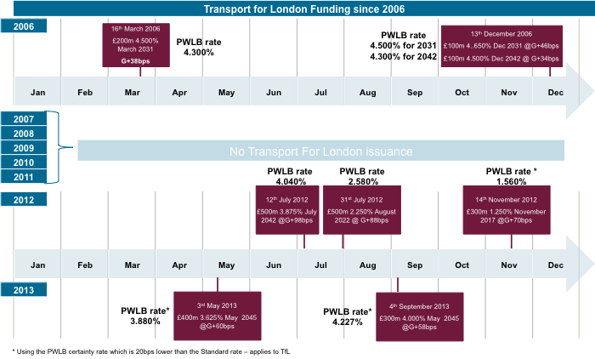

* + 1. Its success in driving its issuance price down from 98basis points over Gilts to 58 basis points over Gilts may be partly due to market movements, but also due to its highly successful and well executed investor relations programme. TfL Bonds have performed strongly in the Secondary Market and are currently priced at 48 to 55 basis points above Gilts.

1 On 7the March 2014, TfL reportedly issued a 50 year, £370 million bond at 55 basis point over the reference Gilt.

* + 1. **University of Cambridge** issued a £350 million bond in October 2012, which priced at 60 basis points above Gilts. The bonds currently trade in the secondary market around 37 basis points above Gilts. Moody’s gave the bonds an Aaa rating, higher than the UK Government.
    2. **University of Manchester** issued a £300mio bond in July 2013, which priced at 80 basis points above Gilts. The bonds currently trade in the secondary market around 42 basis points above Gilts. The bonds received an Aa1 rating from Moody’s, equivalent to the UK Government.
    3. The starting point for pricing discussions on Agency, issuance is likely to be where TfL prices at that point in time, assuming it achieves the same rating.
    4. For the Agency to price at or below TfL, it will need to set out a compelling relative value proposition. The elements, which would drive a compelling relative value proposition, are primarily to do with ratings and structure.
    5. If the Agency has a robust structure, including a Joint & Several Guarantee, and achieves AAA / Sovereign like ratings, then it should price materially below TfL. Estimates of the reduction vary from 5 to 10 basis points at the lower end of the scale to over 20 at the higher end. (A number of commentators have suggested that Network Rail like pricing should be possible.) It should be noted, however, that it would take time to price in the full reduction, given new issue and relative illiquidity premiums.
  1. **Market Movements**
     1. It should be noted that the markets have been seen credit spreads narrow over the past year, as shown in the following chart.



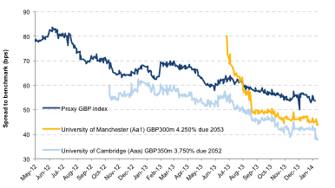



* + 1. This has also seen spreads narrow between AAA and AA, non-Gilt, Sterling issuers

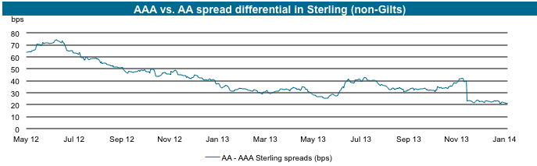

Source: Top 10 Sterling syndicate bank

* + 1. Whilst this narrowing of spreads is instrumental in making the Agency an attractive proposition at this point in time, there remains the risk that spreads will widen again.
    2. This matter should be kept under review as market movement may impact timing and relative competitiveness of bond issuance.
    3. Nevertheless, the spread differential between AA and AAA issuers, would imply that AA issuers are likely to see a larger impact, reinforcing the need for the Agency to achieve AAA / Sovereign like ratings.
  1. **Benchmark size**
     1. The following charts illustrate the difference in pricing between benchmark and sub-benchmark pricing:

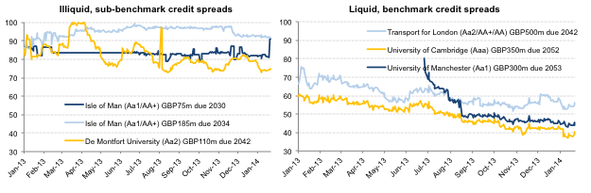

Source: Top 10 Sterling syndicate bank

* + 1. The charts illustrate that the Agency will have to pay up to 20 basis points extra if it is unable to issue in benchmark sizes.
    2. This is driven by a number of factors:
  + A number of potential investors, approximately half, will not invest in sub-benchmark sizes
  + Sub-benchmark bonds are less likely to have an active and liquid secondary market
    1. It is noteworthy that even with Gilts, there is a 6 basis points difference between benchmark and sub-benchmark issuances.
    2. Accordingly, the challenge for the Agency will be to assemble sufficient Local Authority demand to fill benchmark issuances.
  1. **Credit / Structure**
     1. It is in this area where the Agency will have the most ability to influence pricing.
     2. **Credit rating**
        1. In essence, the Agency should aim to achieve a higher rating than TfL and ideally AAA / Sovereign like rating, to achieve best pricing.
        2. Local Authorities are generally considered to be strong credits and none have defaulted. They operate under a strong statutory framework, the Prudential Code, and are viewed as having strong Sovereign support, as evidenced by the activities of the PWLB.
        3. The Agency should continue to build support at Government level, given its very strong Public Interest Case.
        4. Nevertheless, Local Authorities, which have been rated, have typically achieved strong AA, TfL being a case in point, and only exceptionally AAA / Sovereign like.
        5. The default position of a rating agency on a club deal, where a group of Local Authorities came together to issue a bond, would be to assign that bond the rating of the lowest rated Local Authority in the club.
        6. In order to avoid that consequence, the Agency will need significant credit enhancements and, in particular, need to be able to demonstrate adequate:
* Risk Capital / Security
* Liquidity buffer
* Credit Process
* Diversification
  + - 1. It is important not to underestimate the challenge inherent in gaining an AAA / Sovereign like rating.
      2. **Risk Capital / Security**
      3. Whilst the Outline Business Case envisaged that AAA / Sovereign rating could be achieved by having Risk Capital in the amount of 0.6% of the total volume of bonds, we believe that a higher level, of 3 to 5%, would be prudent.
      4. A higher level makes the Agency more comparable with equivalent Scandinavian Municipal Bonds Agencies, which will have to reach a minimum 3% level under CRD IV and would generally provide additional comfort to Investors.
      5. Bondholders will require security for their investments. This can be achieved by any of the following options:
    - Joint and Several Guarantee
    - Each Local Authority guarantees their own borrowings
    - Fixed charge over the Agency’s assets
    - Floating charge over the Agency’s assets
      1. A Joint and Several Guarantee is, by far, the strongest of these options from a bondholder’s perspective. (The implications of a Joint and Several Guarantee, from a Local Authority perspective, are discussed in Section 7.)
      2. A Joint and Several Guarantee materially strengthens the ratings discussions. It immediately evidences the sector’s support for the Agency, which is an important ratings consideration. In addition, it reduces the risk of a bottom up approach to rating, where each borrower is reviewed independently, versus a top down approach where the sector is viewed as a whole. (There are also structuring advantages, which are dealt with in Section 4.)
      3. **Liquidity Buffer**
      4. An additional advantage of the higher level of capital is that it could be held in UK Gilts with equivalent maturities to the Bonds and be available for repo, providing a liquidity buffer for annual coupon payments.
      5. An additional liquidity buffer may be required to secure the highest rating.
      6. **Credit Process**
      7. The Agency will need a rigorous credit process to satisfy a number of stakeholders, in addition to ratings agencies.
      8. Guarantors, under a Joint and Several Guarantee, would want comfort that their guarantee was for strong underlying credits.
      9. Investors will take increasing comfort from knowing that a rigorous credit process is in place. This has significantly helped pricing for housing association borrowers, for example.
      10. More fundamentally, a significant part of the Public Interest Case for the Agency is to raise the credit worthiness of individual Local Authorities. The combination of inviting in peer and external scrutiny, combined with the incentive for lower borrowing costs, can only be enabled by having a rigorous credit process. (Please refer to Section 7.2.3 for a more detailed discussion on the credit process.)
      11. **Diversification**
      12. If the Agency is relying on a handful of Local Authority borrowers, then the individual ratings (shadow or otherwise), of those borrowers will exert increased influence on the rating of the Agency as a whole.
      13. The Agency should aim for as wide a borrower base as is possible for the early bond issues. It will be important that this is not done at the expense of reduced rigor in the credit process.
      14. Over time, as the Agency develops, it may be appropriate to consider limits on concentration risk.
  1. **Structure**
     1. Investors dislike complexity. They will have limited resources to review each new Bond deal, so incremental elements which need to be explained, will reduce their appetite to invest
     2. Successful issuers typically use Medium Term Note Programmes, which is the commonly used framework for issuers who envisage a series of bond issues. The key advantages are that the structure works for ongoing bond issuance and reduces the need to develop new documentation for each issue.
     3. The Agency would also have the opportunity to tap each issue, i.e. borrow more through increasing the size of an issued bond, if desirable, in future funding rounds. (The disadvantage is that they cost more to set up, versus a single bond issue. However, ongoing costs are lower.)
     4. Bond issuance should be done out of a stand-alone financing vehicle. That vehicle would also be responsible for lending to local authorities, managing risk capital and Liquidity buffers. (Services, i.e. staff, IT etc. would be supplied out of an operating entity.)
     5. Joint and Several Guarantees, or other security, would be for bonds issued from that vehicle and the ratings would be for the vehicle as a whole.
     6. A Joint and Several Guarantee enables the Agency to take advantage of the Local Authority exemption under the UK Listing Rules. This exemption limits the volume of disclosure in the Listing Prospectus.
     7. This allows reduced complexity in the Listing Prospectus, reducing the volume of information, which each Local Authority would be required to supply, and consequently the level of review required from legal advisors and investors. This becomes increasingly critical as the number of borrowers increases, carrying the risk that each bond issuance would look different and require ongoing detailed review by legal and investors.
     8. If, instead of a Joint & Several Guarantee model, the Agency were to issue on the basis that each Local Authority guaranteed its own exposure, then the Agency might, nevertheless, be able to take advantage of the Local Authority listing exemption. That would, however create additional risk and be subject to negotiation with the UK Listing Authority. If security were only provided by a fixed or floating charge, that would prevent the Agency from taking advantage of the listing exemption and would, de facto, preclude the Agency from being able to list on the London Stock Exchange, due to the onerous disclosure requirements. That would then require the Agency to consider listing on an overseas exchange, such as Jersey or Luxembourg.
     9. The Medium Term Note Programme would require a paying agent and trustee. All elements should conform to industry standards and use recognised names, including legal advisors, auditors, etc.
     10. The bond issue should avoid complex repayment profiles etc. and simply be bullet repayment at final maturity with a fixed coupon. (Underlying loans to Local Authorities would need the same profile).
     11. Successful bond issuance programmes typically have a number of banks involved in the syndication process. This is important to ensure adequate

secondary market support.

* 1. **Relative illiquidity / New issue premium**
     1. Relative illiquidity relates to the volume of bonds in issuance and coverage of the maturity profile.
     2. TfL’s bond issuance is instructive in this regard. Over a 2 year period they have issued £2 billion in bonds, in benchmark sizes over a range of maturities. In 2012 they issued bonds in maturities of 30 years, 10 years and 5 years, whereas in 2013 they issued 2 bonds at 32 year maturities.
     3. A new issue premium is to be expected as the investor base builds out and they become familiar with the bonds.
     4. Active secondary market support also ensures ongoing price transparency, which helps in both pricing bonds and encouraging investor interest.
     5. An ongoing bond issuance programme and a professional approach to investor relations should ensure that these additional spreads tighten within 1 to 2 years.

# Market Entry Strategy

* 1. **Key Conclusion on Market Entry Strategy**
     1. The previous sections covered in detail the elements, which were likely to influence pricing and this should inform the market entry strategy.
     2. The initial bond is likely to price higher, due to the new issue premium, and accordingly, should be at benchmark size, £250 million at a minimum and ideally £300 million+. It should be noted that even the first bond should target delivering savings to Local Authorities, so it should be advantageous to participate.
     3. The Agency should target a programme of regular issuance and aim to issue on a regular basis in the first couple of years. In the first 12 to 18 months, the Agency should cover a range of maturities, in order to build a yield curve and deliver liquidity to the market.
     4. Whilst it is not necessary to issue bonds every year to maintain a market presence, it would be expected that the Agency would issue bonds every 6 months, at least in the early stages.
     5. Local Government demand for funding is highest in March / April and then again in September / October. The Agency should aim to issue bonds in those periods in order to maximise Local Authority participation and reduce the risk of not being able to achieve benchmark size / excessive concentration of borrowers.
     6. Consideration will need to be given to the optimum maturity profile of the early bonds. Two factors will influence this decision, which would need to be reviewed at the time:
  + Demand from local authorities, within individual maturities
  + Investor demand, which may vary by maturity

.

* + 1. The ability to issue shorter dated paper is only likely to open up to the Agency after a period of time. For these, regulatory treatment and Bank of England repo eligibility, and therefore secondary market liquidity, become factors, given the potential investor base.
    2. Discussion should be held with the PRA and Bank of England in due course when the structure is finalised, and ratings established etc.

# Joint & Several Guarantee: Business case

# This section summarises the benefits of a Joint & Several Guarantee, which have been alluded to elsewhere in this report.

* + 1. The concept is that council borrowers from the Agency would, as well as guaranteeing their own borrowings, participate in a collective guarantee of their fellow borrowers’ obligations. Shareholders would not be participants in the guarantee, unless they are also borrowers. The issues this raises involve a balance between the benefit of the guarantee in terms of investors’ perceptions of the Agency’s bonds, the Agency’s credit rating, and therefore the price of the bonds; and the potential implications for borrowers in the event of the guarantee’s being called. As the following Sections 7 and 8 show, the pricing benefits are very significant, while the implications for borrowers are more nuanced than may at first appear.
    2. The previous outline business case presented a very limited consideration of the case for asking borrowers from the Agency to be part of a Joint and Several Guarantee arrangement. The key consideration is whether a Joint & Several Guarantee can significantly improve investors’ perceptions of the quality of the Agency’s bonds, and thus drive down spreads. It should be noted that whilst the Agency may achieve AAA / Sovereign like rating without a Joint & Several Guarantee, the Joint & Several Guarantee will have a significant impact on driving pricing downwards and is likely to have a greater impact on pricing than the rating, i.e. even with strong AA rating, the Agency could expect pricing in the ‘conservative’ range.
    3. We have conducted extensive conversations with banks and rating agencies on this point. There is a very strong consensus that a Joint & Several Guarantee will have a material impact on perceived credit quality, possibly on actual rating, and on price. Accordingly, borrowers from the Agency could have a reasonable expectation of savings of 20 to 25 basis points, under a Joint & Several Guarantee (See Section 8 for detailed calculations.) This represents our best and conservative estimate based on the discussions with the financial sector, which we have held.
  1. **Bond Structure**
     1. There are some other benefits from a Joint & Several Guarantee which are also relevant to the attractiveness of the bonds to investors. Such a model would allow the Agency bonds to be listed on the UK Stock exchange availing of the Local Authority exemption. The exemption limits the volume of disclosure required in the listing prospectus from Local Authority issuer, which for the Agency, with multiple underlying borrowers would become onerous and add significant cost and complexity

1. **Joint & Several Guarantee: Protection in place for guarantors** 
   1. **Key conclusions from this section are as follows:**
      1. There are a number of elements which mitigate the risks of a call on the guarantee:
   * The risk capital, liquidity and credit processes of the Agency
   * Statutory and budgetary controls of Local Authorities
   * The Prudential Code and Minimum Revenue Provision
   * Responsibilities of Finance Directors (Section 151 officers),
   * Access to the PWLB, and
   * Government reserve powers
     1. For the guarantee to be called upon, an unprecedented scenario would have to occur. In particular, both the processes of the Agency and statutory controls over the individual Local Authority finances would have failed and Government support evaporated.
     2. Security over borrowing and the High Court process: Even if the guarantee is called upon, for the guarantors to suffer a permanent loss greater than £10,000, the receiver appointed by the High Court to administer a local authority in default, would have to be unable to recover those sums from its revenues.
     3. Proportionality / Right if Recourse: Although the guarantee is Joint and Several, English law and the terms of the guarantee would enable authorities that are held liable under the guarantee to recover proportionate sums from other authorities who are party to the guarantee.
     4. We have obtained legal advice and opinion from Allen & Overy on the operation of the Joint & Several Guarantee, which has been informed this section where appropriate.
   1. **Risk Capital, Liquidity and Credit Processes of the Agency:**
      1. **Risk Capital / Liquidity**
         1. “Hold backs” (a portion of a loan taken out by a borrower, but not paid over by the lender) equal to 3 to 5 per cent of the loans made to Local Authorities will be retained by the Agency. The hold back will be accounted for as subordinated debt to provide additional risk capital:
      * The subordinated debt will be invested in Gilts matching the maturity of the loans thereby eliminating maturity risk.
      * In the event of a likely default by a local authority, the Gilts will be used to provide liquidity via a repurchase agreement (“repo”) to meet any shortfall on the bond payments.
      * In the event of default by a local authority, only once the equity and subordinated debt have been exhausted will the Agency need to call upon the guarantee.
      1. **Credit Processes**
         1. The Agency will maintain its own credit scoring process and monitoring procedures; unlike the PWLB, the Agency will not be indifferent to the financial performance of local authorities:
   * The process will be rigorous, but as the Agency will have a thorough understanding of UK local government it should not place heavy demands on Local Authorities.
   * The Agency will develop credit scoring processes, with the intention to lend to financially strong Local Authorities. (Indicatively, the Agency would expect any of its borrowers to be able to achieve a AA- rating, on a stand alone basis, allowing for size.)
   * Those authorities with significant liabilities, where it is unclear how they will be met and the regulatory position opaque, will not be able to access the Agency irrespective of any external credit rating.
   * Local Authorities will be required to confirm adherence with the Prudential Code and provide greater financial information than that provided to the PWLB.
   * After the initial bond issues have been completed, the Agency will cap its exposure to any single authority in order to reduce its “concentration risk” i.e. it will try and ensure that default by a single borrower cannot cause the guarantee to be called upon.
     + 1. Taken together, these measures will both ensure that the Agency is aware of any financial difficulties faced by a Local Authority and that no Local Authority is able to “free ride” off the guarantee offered by other others.
       2. A rigorous credit process is not synonymous with onerous. The Agency will specialise in local government finance and have an ongoing relationship with the LGA regarding developments in local government.
       3. Therefore, many of the necessary, but onerous, demands placed upon Local Authorities undertaking a formal credit rating for the first time will not be required. For example, the Agency understands how Local Authorities are structured and can access financial settlement data itself.
       4. As it is specialist, the Agency is likely to concentrate on certain key credit issues rather than attempt a “comprehensive” understanding of each Local Authority. The key issues are likely include:

* The debt burden borne by the authority.
* Budgetary soundness.
* How long term liabilities, such as pension deficits, will be funded.
* Timely and accurate publication of financial reports and information, with a clean audit opinion.
  + - 1. In the short term, unless there are significant changes to the Business Rates Retention Scheme and / or system of local government finance, the Agency is unlikely to be too concerned with the following unless there are specific grounds for doing so:
* Property values – a Local Authority cannot mortgage its assets and its revenues are not linked to property prices (but the Agency will want copies of valuation reports).
* The local economy – Local Authority tax raising powers are not linked to the state of the local economy and exposure, under the Business Rates Retention Scheme, is subject to a safety net.
  + - 1. Any internal credit score and / or outcome of Agency processes will remain confidential to the Agency and that authority. Over time, the Agency may pre-screen Local Authorities, based on publically available information, in order to reduce on-boarding timelines.
      2. Accordingly, whilst borrowing from the Agency will require Local Authorities to devote a certain amount of resource to the Credit Process, it would be expected that this would be materially less than that required to support an external rating.
      3. As with an external rating, that level of resource would reduce over time as the Agency became increasingly familiar with the individual Local Authority.
      4. The process will become increasingly efficient as the Agency develops sector wide tool sets, which access publically available data for initial credit review and monitoring purposes.
      5. In due course, the Agency would expect to develop scoring models, more akin to those used by Banks for credit purposes and borrowing from the Agency is likely to be no more onerous than borrowing from a bank, albeit with limitations as to flexibility etc.
  1. **Statutory and Budgetary Controls of Local Authorities**
     1. There is a range of controls designed to prevent a Local Authority from defaulting on its obligations. In addition, there are legislative measures that are likely to ensure that even if a Local Authority does default, its creditors are able to recover sums owing to them.
     2. There is a hierarchy of protections set out in the following pages. Each must fail before a guarantor faces an ultimate loss greater than £10,000.
     3. Limited Powers to Borrow and Prohibition on Deficits:
     4. The Local Government Act 2003 and associated Local Authorities (Capital Finance and Accounting), (England) Regulations 2003 (usually referred to as the Capital Finance Regulations), together with the Localism Act, 2011*,* impose a statutory prohibition on borrowing to fund revenue expenditure; borrowing can only fund capital expenditure or to undertake “proper” treasury management activities such as the refinancing of debt.
     5. As a counterpart to the restrictions on borrowing, local authorities must set a balanced revenue budget i.e. in cash terms, allowing for contributions to and from reserves, the Council must spend only what it receives in revenue; it cannot run a budget deficit.
     6. Taken together, these two measures prevent local authorities from borrowing to avoid raising taxes or cutting spending, therefore reducing the risk that a local authority will enter financial distress.
     7. The chart below shows that the level of local government borrowing each year is relatively stable and not linked to either the economic cycle or lagging Government expenditure.
     8. **Public Sector and local Government Borrowing**



* 1. **The Prudential Code and Minimum Revenue Provision:**
     1. The ‘Prudential Code’ limits local authorities’ borrowing by forcing local authorities to consider whether borrowing is affordable and financially sustainable. For example, authorities must consider the effect of borrowing costs on its revenue budget, HRA rents and Council Tax. The Code has been developed by CIPFA and has statutory underpinnings via the Local Government Act 2003 and the Capital Finance Regulations.
     2. A key concept of the Prudential Code is the “Capital Financing Requirement” (CFR). The CFR measures an authority’s underlying need to borrow, which is the authority’s existing debt together with an amount that a local authority would need to borrow in order to fully fund its asset base. Local Authorities set aside funds for a variety of purposes and reasons, which, under the Capital Finance Regulations, can be “borrowed” (known as “internal borrowing”) to pay for capital investment. When internally borrowing, the authority may not have either the means to return that sum or have sufficient income to pay for the asset unless specific provision is made to do so. (It needs to be borne in mind that unlike a commercial company, local authority assets are not normally cash generating assets.)
     3. Therefore, to help ensure that local authorities ultimately do pay for their assets, authorities must set aside funds to meet its CFR, which is known as the “Minimum Revenue Provision” (MRP). The level of MRP that needs to be provided is determined by a council’s MRP policy, guided by the Capital Finance Regulations that aim to ensure a local authority provides for a specific debt as it becomes due.” The MRP is a charge against the Council Tax and HRA rents. It is designed to set aside funds to repay debt; it is a form of sinking fund, which significantly reduces the likelihood that any guarantee will be called upon.
  2. **Responsibilities of Finance Directors (Section 151 Officers)**
     1. Section 151 Officers – the finance directors of Local Authorities – have statutory responsibilities to ensure that Local Authorities can meet their obligations as they fall due.
     2. Under Section 114 of the Local Government Finance Act 1988, a Section 151 officer must formally report to the full council or cabinet of a Local Authority when either its expenditure or budgeted expenditure will exceed the resources available to his or her authority. The report is effectively a warning of impending insolvency if action is not taken to rectify the problem.
     3. Under Section 115 of the same Act, the full council or cabinet has to meet within 21 days to consider the report and take action: it must not continue the course of action causing the Section 114 report.
     4. In practice, the following takes place under Section 115:
* If it is a budgetary issue, the council has no choice other than to cut proposed expenditure.
* If it is a question of expenditure as bills fall due, discretionary expenditure has to be cut.
* The Local Government Act 2003 requires a Section 151 officer to perform certain actions to resolve the situation whether or not full council or cabinet has met to determine its course of action. The Section 151 officer must approve all new expenditure and is only allowed to approve expenditure if it will improve the financial position of the authority or not cause further deterioration of its finances.
  + 1. This is a key reason why the guarantee should not be called upon.  Were a Section 151 Officer to fail to issue a report under Section 114 when he or she should have done, the officer could be found to be negligent; were the Local Authority not to take action, all new expenditure would be ultra vires.
  1. **Access to the PWLB:**
     1. Even after the establishment of the Agency, Local Authorities will have access to the PWLB to provide funding that is effectively on demand. This ensures that a Local Authority will always have means to meet principal repayments, because they may borrow to refinance debt. This significantly reduces the likelihood that an authority will default on its principal because it always has means to fund those repayments.
  2. **Government Reserve Powers:**
     1. The Government retains extensive reserve powers in relation to Local Authorities and has consistently intervened well before any financial problems at a Local Authority become critical. To date, the Government has not allowed any Local Authority to default on its obligations.
     2. The Government’s preparedness to stand behind the sector is a key factor in the creditworthiness of the sector and that the guarantee is unlikely to be called upon.
  3. **Security for Borrowing and the High Court process:**
     1. Under Section 13(3) of the Local Government Act 2003, all the liabilities of a Local Authority are secured indifferently on a Local Authority’s revenues. This provides a significant level of security because the Government provides much of a Local Authority’s revenue and the Council Tax, and most fees and charges, is levied on a statutory basis.
     2. If a Local Authority defaults on a debt greater than £10,000 for a period of two months, under Section 13(5) of the Local Government Act 2003 a creditor may apply to the High Court for an administrator to be appointed. The powers of the administrator will be determined by the High Court, but can include:
* Collecting, receiving or recovering the revenues of the local authority
* Issuing levies or precepts; or
* Setting, collecting or recovering Council Tax.
  + 1. This process should ensure that any Local Authority that is called upon under the guarantee can recover the debt via the courts if need be.
    2. **Operation of the Guarantee and Right of Recourse:**
    3. Although the guarantee is Joint and Several, English law (the principle of “equity”) and the terms of the guarantee or supporting agreements will ensure that ultimately, a local authority is only responsible for its proportionate share of any amounts that are paid out under the guarantee.
    4. English law sets out a number of protections that mitigate the effects of the guarantee on any guarantor that is called upon under the guarantee:
* Right of indemnity: once a guarantor has made a payment under the guarantee, it immediately gains a right to be indemnified by the principal debtor.
* Right of subrogation: this allows a guarantor to "step into the shoes" of the bondholders and assume all the rights the bondholders had in relation to the Agency i.e. it can receive payments from borrowers.
* Right of contribution: once a guarantor has paid more than its proportion of the debt, it is entitled to seek rateable contributions from the other guarantors.
  + 1. Underneath the guarantee there will be a right of recourse agreement or similar contractual arrangement that secures reimbursement from other guarantors for any authority performing under the guarantee who pays out more than its proportionate share. The agreement will make it simpler and quicker for a guarantor to secure payments from other guarantors. For example, the right of indemnity is against the Agency, so that right would only indirectly secure reimbursement.
    2. In summary, a bondholder whose bonds are in default may apply to any single authority or group of authorities to meet the terms of the guarantee, but those called upon will be able to recover costs from the other guarantors.
  1. **Vires of a joint and several guarantee**
     1. We are aware that questions have been raised about legal powers of councils to give a joint and several guarantee. We have sought legal advice from leading counsel on this point. The advice is unequivocal that such a guarantee would be within vires, for English councils, available under the General Power of Competence created by the Localism Act, even when subject to the further tests within that Act and the existing case law.

# Pricing Strategy

* 1. Pricing considerations should be driven by the need for the Agency to deliver savings to its Local Authority borrowers, whilst covering its operating and bond related costs sufficiently, to generate a profit.
  2. Local Authorities would expect, and the Agency should deliver, a simple and transparent pricing mechanism.
  3. The starting point for pricing will the interest rate at which bonds are issued.
  4. In addition, it will be necessary to add:
  + Costs which are specific to the bond being issued, and
  + A margin to cover the Agency’s operating costs and generate a profit.

# Indicative Borrower Economics

# The following table shows the indicative savings to Local Authority borrowers, dependant upon Agency Bond pricing, based on these principles1

# 

# Costs, which are specific to the bond being issued, include syndicate fees, ratings fees, administration costs to manage the bond issuance on an on going basis, i.e. trustee, payment agents etc. (In due course, it may prove advantageous for certain of these costs to be covered within the Agency Operating Cost margin directly, for example it may be cheaper to pay an annual relationship fee to a rating agency, rather than pay a basis points fee on each bond issued. Decisions in this respect can only be made following price negotiations with various providers.)

* + 1. This model proposes a margin of 10 basis points to cover the Agency’s operating costs. Whereas, in the early years, this will not be sufficient to cover costs, once the Agency has achieved £2 billion in bond issuance, it should move into profit. (See Section 9 on Operating Model and Timeline).

1 On 7the March 2014, TfL reportedly issued a 50 year, £370 million bond at 55 basis point over the reference Gilt.

* 1. **Evolution of pricing**
     1. As the volume of bonds issued by the Agency increases, it should be possible to reduce certain margins, delivering increased savings to Local Authority borrowers. In effect, the costs of the Agency should not rise directly in line with the volume of bonds
     2. The Board of the Agency should review pricing regularly, and at least annually, to ensure that there is a fair distribution of the benefits of volume increases back to borrowers
  2. **Variable pricing**
     1. Some Municipal Bond Agencies adjust pricing for individual Local Authorities, based on internal agency credit scoring, for example. This acts as an added incentive for Local Authorities to improve their creditworthiness
     2. We have briefly reviewed this concept and believe it is not appropriate for the Agency, at this point in time
        1. The margins available to the agency for variable pricing are likely to render any differentiation largely negligible, i.e. individual basis points
        2. It may run the risk of being viewed as an internal subsidy between Local Authorities
        3. The Agency will have a rigorous credit process, where all borrowers are likely to be of a largely equivalent credit standing
        4. There was no real appetite amongst Local Authorities for a variable pricing structure
     3. Nevertheless, the Board of the Agency may wish to reconsider this topic, from time to time

# Operating Model and Timeline

* 1. The key conclusions with respect to Operating Model and Timeline are as follows:
  2. **High level timeline**
     1. The Agencies Operating Model and related timelines should be considered over a number of phases:
* **Mobilisation phase:** Establishing the Agency and its Corporate Structure.
* **Launch phase:** The initial 2 year period where it begins to establish its market footprint, both amongst investors and Local Government Borrowers.
* **Development phase:** where it begins to build out its range of lending services, e.g. Commercial Paper Programme, more flexible funding arrangements, etc.
  + 1. This paper predominantly deals with the first 2 phases, Mobilisation and Launch. The focus for the Agency in the early years should be entirely on building out its footprint. This becomes a key enabler for the Development phase, which is, in effect, only possible when the Agency has a sufficiently large client base, i.e. up to 100 borrowers and an established bond programme covering a wide range of maturities, with a higher degree of certainty over pricing.
    2. From today, we can view the high level timeline for the next 2 years as follows:

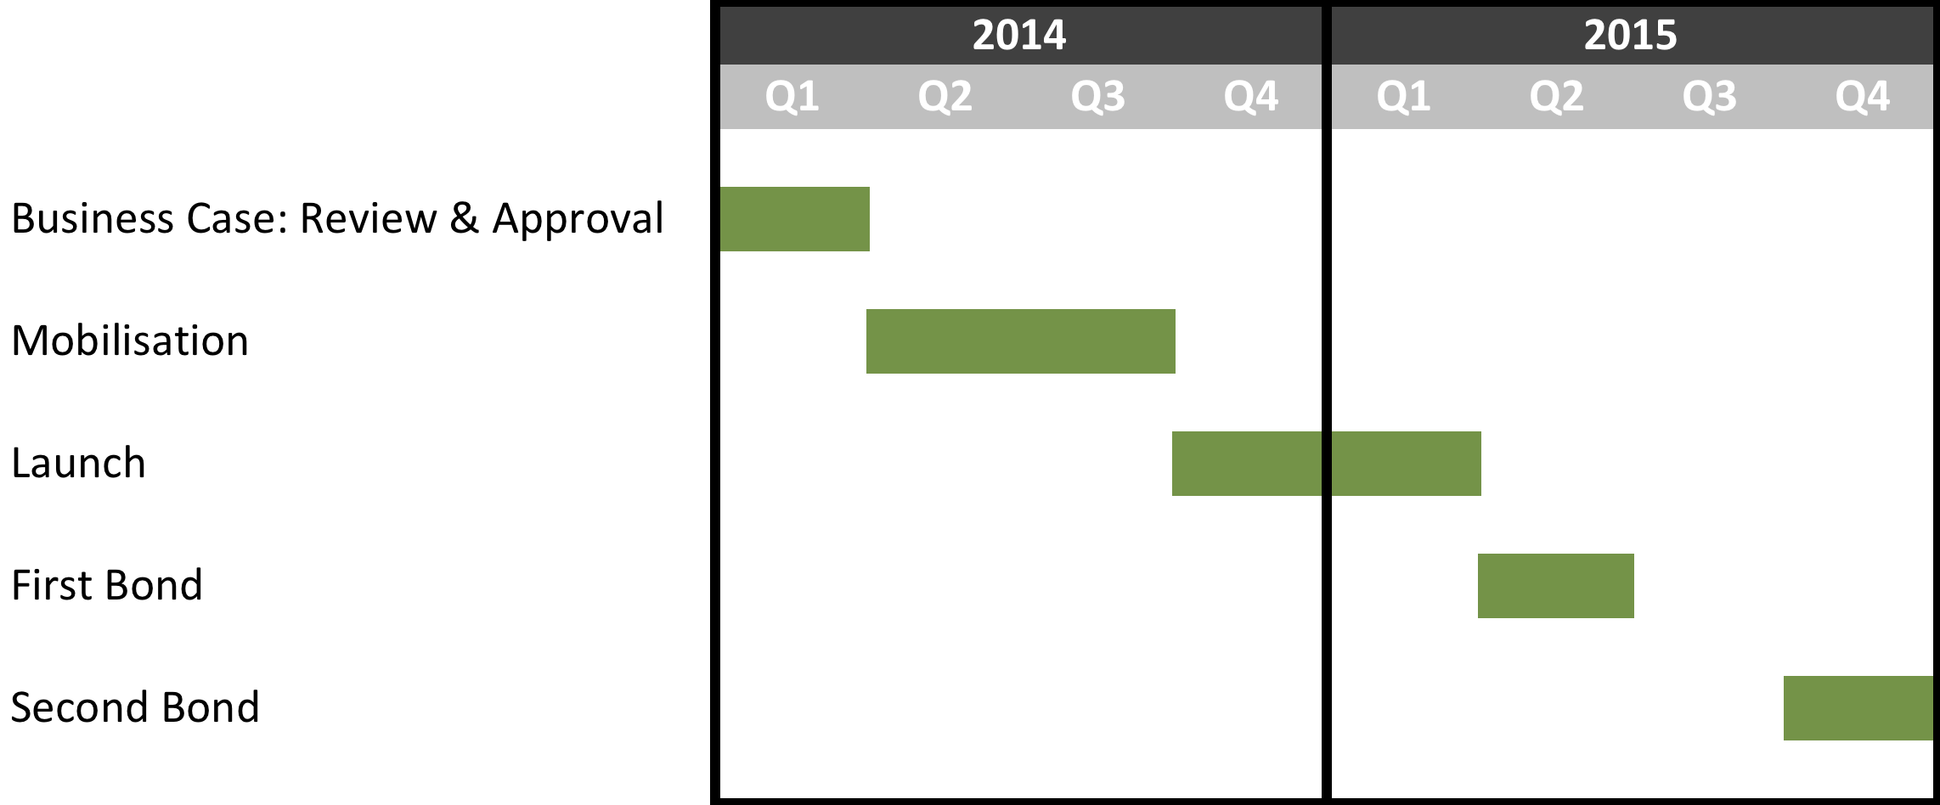

* + 1. It is unlikely that the Agency would be in a position to move into the Development phase until 2017, at the earliest. That phase would see a significant increase in the complexity of the Agencies operations, and should be subject to a detailed business plan at that point in time.
    2. It should be noted that this timeline significantly compresses that envisaged in the original Outline Business Case, by more than one year. There are a number of reasons for this:
  + The optimum timing for Bond issue is driven primarily by the profile of Local Authority borrowing, the highest volume of which occurs in March / April, with September / October being the next high point. The timing of any bond issuance, subject to market conditions, should be planned to coincide with these high points.
  + The syndication process, i.e. actually selling any bond into the market, should take 3 months, at most. Accordingly, the key challenge for the Agency will be to lock down a core group of initial borrowers by January 2015.
  + The initial group of borrowers should be identified during the mobilisation phase, ideally 20+ Local Authorities, with over £10 million demand each.
  + Detailed bond structuring, including a preliminary rating should be completed in Q4 2014, for the syndication process to begin in January / February, 2015.
  + Accordingly, the end of Q3 2014 should see completion of the Agency’s corporate structure and capitalisation.
    1. Whilst this timeline is ambitious, it is important to maintain the level of momentum, which has built up. Hence the recommended mobilisation phase. In addition, the shorter timeline reduces the level of resource put at risk, should the process abort for any reason.
    2. There are 5 key risks associated with the early stage of the project:
  + It may not be possible to raise the required level of operating capital,
  + Local Authority demand for the Agency may not materialise in sufficient volumes,
  + Market pricing, for any bond issuance, may not be attractive,
  + The PWLB may reduce the margin over Gilts sufficiently to render the Agency an unattractive choice for Local Authority borrowing, and
  + The Agency may not be able to attract personnel of sufficient calibre on a timely basis.
    1. Each of these risks is covered in more detail in Section 10. Where relevant, we have attempted to estimate the associated abort costs and point in time at which a decision should be made.
  1. **Key Assumptions used in the Operating Model / Financial Model**
     1. The operating model and financial model are driven by the anticipated volumes of transactions and required level of resource to support:
     2. **Bond Issuance, anticipated programmes, post launch**

Year Timing Volume Number of Borrowers

2014 March / April £250 million 20+, new

Sept / Oct £250 million 20+, 50% new

2015 March / April £500 million 20+, 50% new

Sept / Oct £250 million 20+, 50% new

2016 March / April £500 million 20+. 50% new

Sept / Oct £250 million 20+, 50% new

* + 1. Accordingly, in year 3, post launch, the Agency would expect to have £2 billion in bond volume, supporting loans to 70+ Local Authorities, and representing a market share of approximately 25% of Local Authority annual funding requirements.
    2. In order to cover its costs, the Agency will require a margin to be included in interest charged to Local Authority borrowers. The initial margin is set at 10 basis points, so, for example, at £2 billion in Bonds issued, the Agency will have £2 million in income to cover operating costs.
    3. The Agency platform should be scalable, i.e. grow volumes, without a corresponding increase in operating costs. Accordingly, it would be anticipated that the margin required would reduce over time as volumes permit.
    4. **High Level Operating Model**
    5. The level of bond issuance and related Local Authority lending should guide decisions around the level of resources required in the initial phases.
    6. **Key Functional Roles**
    7. The key functional roles, which are required in the early stages, are as follows:
    8. CEO – Provide strategic leadership to the Agency and be its main representative with stakeholders: Local Authority borrowers, bond investors and shareholders
    9. CRO – Responsibility for management of key risks, particularly Credit and Operating Risk in the early stages. The key initial responsibility will be developing a credit approval policies and process for the initial borrowers.
    10. CFO / CAO – Responsible for financial management and reporting. In addition, should be responsible for managing supplier / outsource relationships, including bond related.
    11. Marketing Local Authorities – Supporting the CEO in ensuring a pipeline of potential Local Authority borrowers is developed.
    12. Administrative support – Responsible for office management and administrative support for the team.
    13. As the volume of business develops, additional staff will be required to support the volume of work.
    14. As the Agency moves into the development phase, it is likely be necessary to implement a sophisticated treasury management process and systems. Additional staff will also be required to deal with increased Local Authority interface.
    15. **Outsourcing arrangements**
    16. Given the likely volume of transactions in the early years of the Agency, it is unlikely to be economic to maintain a number of the required support services ‘in-house’.
    17. In particular, IT, HR, Legal should in the first instance, be outsourced. This should be kept under constant review to assess whether the volume of resource, particularly legal, required justifies an internal hire. It may also be appropriate to outsource accounting services.
    18. In addition, all elements relating to servicing bonds and Local Authorities should be outsourced in the first instance. Specifically, this would include receipt and disbursement of all principal amounts between bond investors and Local Authorities and related interest payments. In particular, this mitigates the risk of having large volumes of cash being controlled within the entity.
    19. **Bond related costs**
    20. The following estimated costs are not considered as part of the Agency costs, but part of the bond issuance costs:
  + Syndication costs: 12.5 to 30 basis points of bond volume, depending upon maturity. These would typically be amortised over the life of the bond, ~2 basis points per annum
  + Ratings fees: Depending upon number of ratings agencies etc., each of which have different pricing mechanisms. For the purposes of this exercise, ratings fees are assumed to amount to 8 to 10 basis points per bond issue, amortised over the life of the bond, ~1 basis point per annum.
  + In pricing discussions with ratings agencies, it may be preferable to pay an annual relationship fee, rather than by bond, in which case the costs may become a direct cost to the Agency.
  + Paying agent, Trustee services etc. approximately 1 to 2 basis points per annum
    1. Legal fees are considered as part of the costs of the Agency.
    2. **Mobilisation Costs**
    3. Mobilisation costs are estimated at approximately £800 thousand, see below.

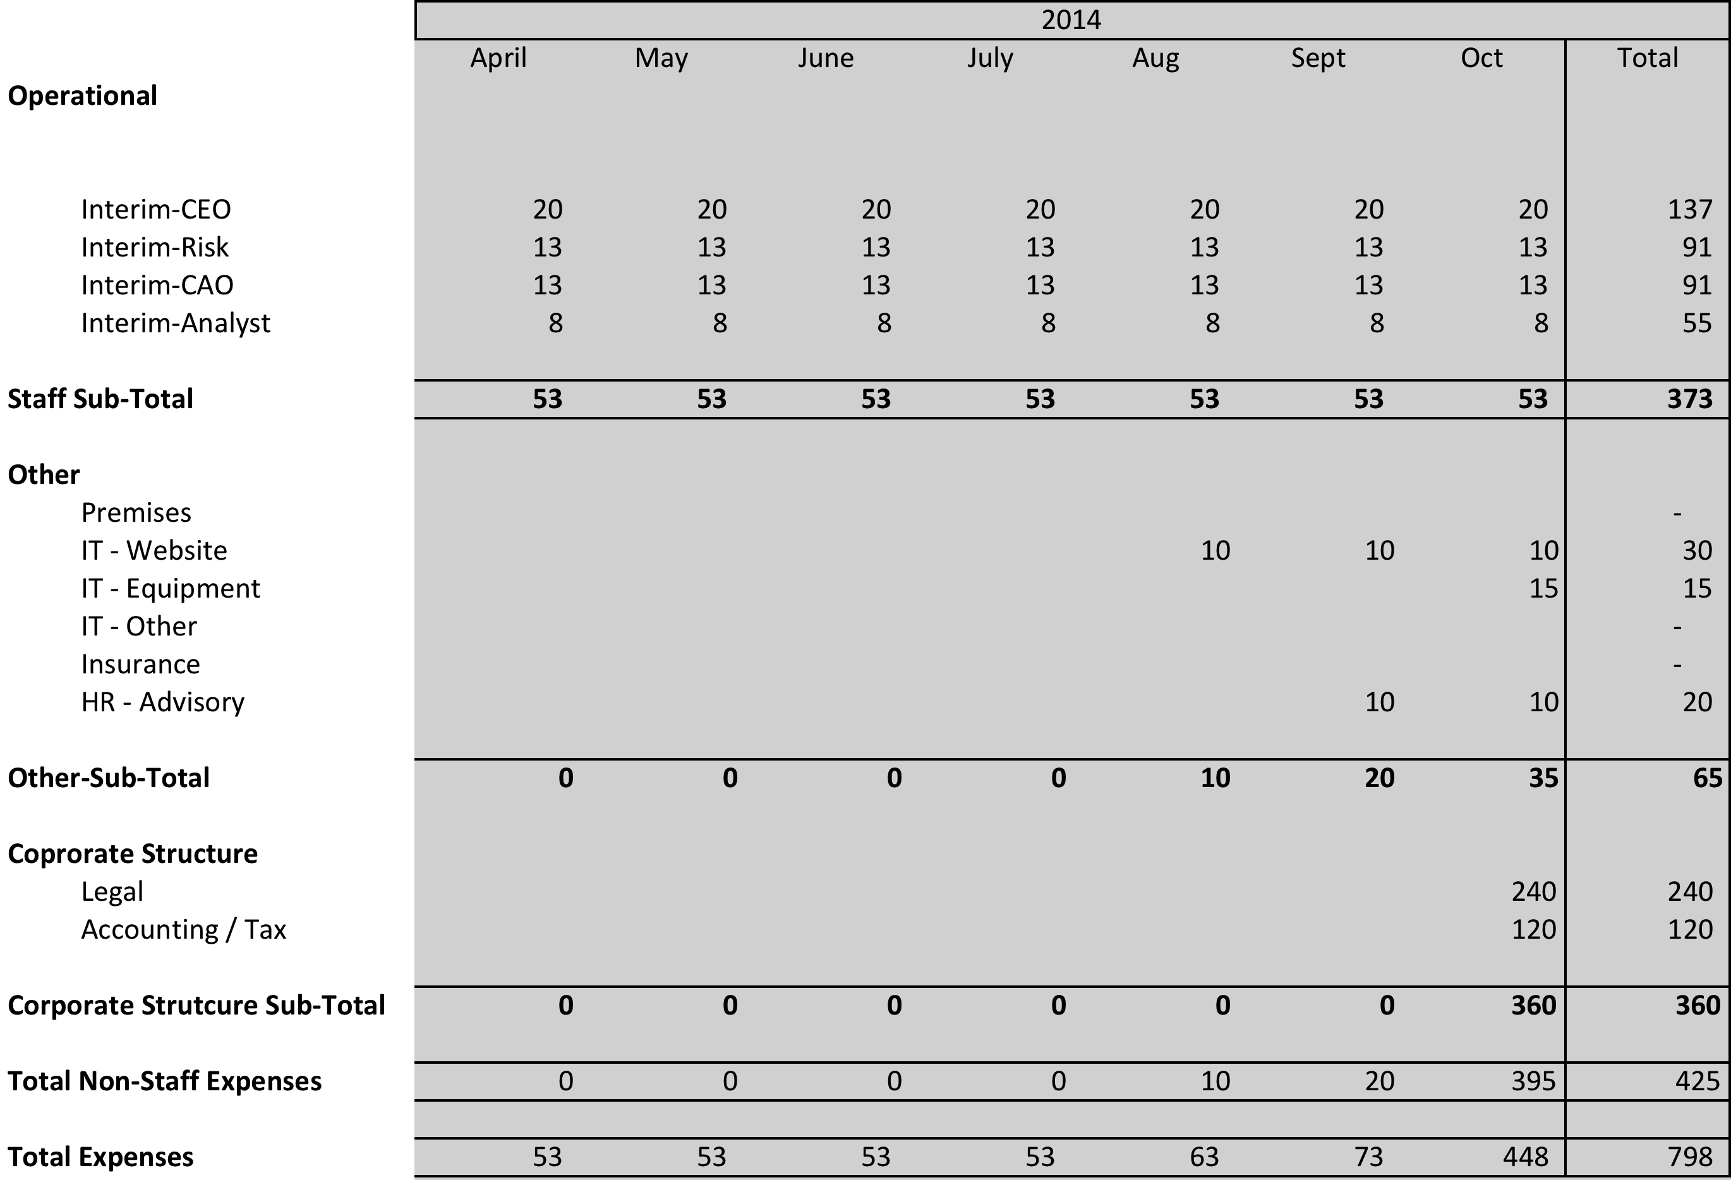

* + 1. It is assumed that the LGA continue to house the Agency, e.g. provide IT support and Premises, until launch. Given the requirement to set up the legal entity structure, this is likely to be a requirement, in any event.
    2. Mobilisation will have 5 broad objectives:
  + Establish the corporate structure.
  + Identify the initial set of borrowers.
  + Commence the selection of 3rd party suppliers / outsource arrangements.
  + Commence hiring permanent staff.
  + Complete drafting of Policy, Procedures and Process manuals.
    1. In addition, the Agency should develop detailed communication plan as a part of this process to ensure the widest possible engagement of the sector.
    2. Whilst it would be anticipated that experienced interim staff should complete all documentation to a high standard, the Agency may want to hire 3rd Party consultants for review purposes. No provision is included in the plan for such costs.
    3. Mobilisation is assumed to have a one-month overlap with the hire of permanent staff, for hand-over etc. Costs include estimates of agency fees, VAT etc.
  1. **High Level Financials**
     1. High level, 6 year forecast P&L (£’000) for the Agency, are as follows:

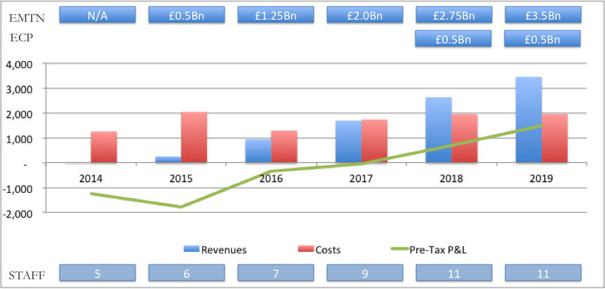

* + 1. It is assumed that the Agency will take a fixed margin of 10 basis points on all term lending and 5 basis points on lending related to the ECP programme. All other income and expense related to the bonds is not included in this forecast P&L, as in effect, the intention will be to pass back any benefits of improved pricing to the Local Authority borrowers, i.e. the Agency will have no economic interest in the bonds per se.
    2. The Agency achieves breakeven in 2017 / 2018, when bond volumes begin to reach £2 billion. The Agency is assumed to capture 25% market share on an estimated £3 billion of Local Authority borrowing demand.
    3. Total costs to breakeven are estimated at £3.5 to £4 million. (2014 costs include mobilisation.)
    4. The significant increase in costs in 2015 is primarily driven by estimated legal expense required to establish the EMTN programme and initial ratings.
    5. **Summary of Costs: 2014 to 2019, £000’s**
    6. Six year forecast costs (£’000) for the Agency, are as follows:

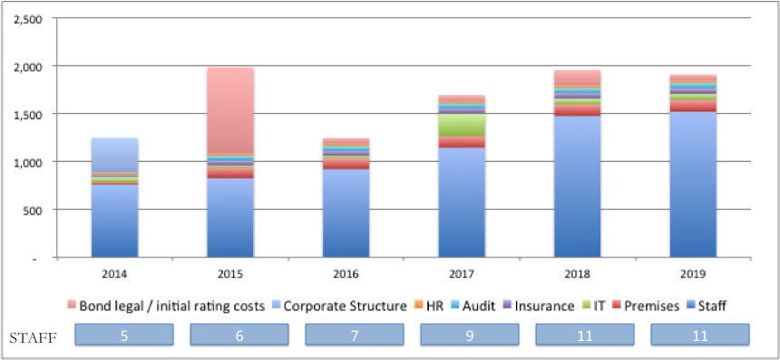

* + 1. Costs are predominantly driven by staff costs, with the exception of legal and ratings costs, related to the set up of the EMTN programme in 2015, and corporate structuring costs on 2014.
    2. Staff costs are anticipated to build up slowly as the Agency develops. A business case will need to be prepared and approved by the Board for any business development. Nevertheless, there is an anticipated spend of £200 thousand technology spend and increased staff levels in 2017, to deal with upgrades which may be required to support an ECP programme.
    3. Mobilisation costs are included in the 2014 spend.

# Key Financial Risks and Related Mitigants

* 1. There are 5 key risks associated with the early stages of the project:
     + It may not be possible to raise the required level of operating capital,
     + Local Authority demand for the Agency may not materialise in sufficient volumes,
     + Market pricing, for any bond issuance, may not be attractive,
     + The PWLB may reduce the margin over Gilts sufficiently to render the Agency an unattractive choice for Local Authority borrowing, and
     + The Agency may not be able to attract personnel of sufficient calibre on a timely basis.
  2. **It may not be possible to raise the required level of operating capital**
     1. This should become apparent during the mobilisation phase. Whilst £8 to 10 million is considered the optimum sum to ensure adequate cover for potential cost overruns or delays, the Agency could consider establishing itself if £5 to 6 million were raised, albeit with material incremental execution risk.
     2. During this phase, all staff will be on interim contracts, with an estimated monthly expense of £53 thousand.
     3. If there is not sufficient visibility on the capital raise, there will be no need for legal and other advisory costs related to the corporate entity structure, nor developing a website, eliminating £420 thousand of the mobilisation spend.
     4. Accordingly, the level of resources at risk is ~£400 thousand
     5. The Project Board overseeing the mobilisation project should review regularly, with a view to aborting the project if capital cannot be raised.
  3. **Local Authority demand for the Agency may not materialise**
     1. The level of Local Authority demand should be assessed during the mobilisation phase. Specifically, Local Authorities should be asked for soft commitments during this phase, in order that the initial book of borrowing, to support the first bond issue, can be identified.
     2. The Agency will need to be able to issue in Benchmark sizes, i.e. £250 to £300 million, to optimise pricing, and should aim to issue a single bond with a fixed maturity.
     3. A challenge, at this point in time, will be a lack of visibility over pricing. Nevertheless, visibility on potential pricing should improve as time elapses and borrowers should be able to take a view with pre-determined ranges.
     4. The level of resource at risk, and potential approach during the mobilisation phase is the same as above, i.e. the risk of not raising sufficient capital.
     5. In Q4 2014, it will be necessary to lock down harder commitments, i.e. execute borrowing documents, guarantees etc., albeit subject to pricing risk considerations.
     6. Should demand evaporate at this stage, the Agency will have used approximately £800 thousand in mobilisation costs.
     7. In addition, the Agency will have on-boarded staff etc. so it is reasonable to assume that up to one year’s operating expense will, additionally, be at risk, i.e. £1.3 million, excluding bond related legal / ratings costs.
     8. The Agency should be able to mitigate some of these costs, through shorter-term contracts etc.
     9. Accordingly the level of resource at risk is £400 thousand or less, if insufficient demand during the mobilisation period and up to ~£2 million, if identified later in the process.

* 1. **Market pricing, for any bond issuance, may not be attractive**
     1. Whilst the Agency should continue to monitor pricing developments during the mobilisation phase and up to the end of Q4, 2014, the syndication process is only likely to begin in earnest in Q1 2015.
     2. At that point in time, the major risk to bond pricing will be that of market movements, Whilst there may be some risk that the structure etc. will not appeal to investors, that risk should have been largely closed out in ongoing discussions with potential syndicate banks.
     3. Whilst the level of resource at risk is broadly the same as the above for Local Authority demand evaporating at a later stage, the Agency is also likely to have incurred significant legal and ratings costs. Accordingly, the level of resource at risk is up to £2.9 million.
     4. In the event of a bond being pulled at the latter stages in the process, it is unlikely that syndicate banks would require conditional fees.
  2. **The PWLB may reduce the margin over Gilts rendering the Agency unattractive for Local Authority borrowing**
     1. The level of resource at risk, in this scenario, will very much depend upon the point in time such a reduction occurs.
     2. There is a strong public interest supporting the Agency and, indeed, many good reasons to pursue the Agency, regardless of PWLB pricing. In addition, during the mobilisation phase, the Agency and its sponsors should actively build support for the Agency amongst politicians.
     3. Nevertheless, if the core product of fixed term lending is rendered unattractive, from a pricing perspective, to Local Authorities, it will become challenging to build the required volumes to support the Agency.
     4. If PWLB pricing reduces before the Agency issues its first Bond, then the sunk costs are likely to be similar to the above, i.e. between £400 thousand and up to £2.9 million, depending upon the point in time at which pricing is reduced.
     5. In the event that the Agency has issued a bond, then it may be possible to reduce costs to a point where trail revenues exceed costs, providing some mitigation to sunk costs.
  3. **The Agency may be unable to attract personnel of sufficient calibre**
     1. There is a risk that appropriate candidates may not be identified for critical roles on a timely basis.
     2. The Agency may need to be flexible on salary levels and contract structure, given the inherent risks for any candidate in joining the Agency.
     3. Nevertheless, the Agency will be a high profile opportunity, so this risk is somewhat mitigated. In addition, there are likely to be suitable candidates available in the interim market to cover.
     4. Accordingly, whilst this is a risk, which needs to be overseen, it is not considered likely to result in aborting the project.
     5. This does, however, represent a risk to cost estimates, should the need for more expensive staff or 3rd party advisory services be required

# Capital Structure

* 1. **Two forms of Capital will be required:**
  + Operational Capital: to meet set up and operating costs of the Agency until it achieves profitability, and
  + Risk Capital: required to support first loss absorption, in the event of default and, therefore the Bonds credit rating
  1. **Operational Capital - £8 to 10 Million**
     1. It is recommended that this be held in the form of Common Equity.
     2. The Outline Business Case envisaged that this would be in the form of subordinated debt, carrying a fixed coupon, with repayment of principal from the operating profits of the Agency over time. Each contributor to the required subordinated debt would receive 1 share.
     3. Whereas, this may be a workable structure, it leaves open a number of challenges:
* The requirement to pay interest on debt before the Agency generates a profit materially increases the execution risk as working capital is absorbed
* The personal risk of the directors, i.e. in the event that the Agency did not attract sufficient volumes, then structurally it would become insolvent
* Lack of linkage between the economic ownership of the Agency and the level of investment, i.e. an investor receives a single share regardless of commitment
* What value would attach to each share and how would future membership be priced?
  + 1. An alternative would be to raise common equity, which would materially mitigate the above risks. In addition, a common equity structure would enable the following:
  + Share transfers, should shareholder wish to reduce their holding
  + Allow for new shareholders to come on board, i.e. buy shares in the Agency, using transparent and fair valuation principals. (Bond investors and ratings agencies are likely to look favourably on a broader shareholder base, as a means of demonstrating the commitment of the sector to the Agency. Indeed the Agency, itself, is likely to benefit from having broader commitment from the sector.)
  + Give the Agency an enabling solution to make decisions with respect to the level of profit retention, dividends, capital raising etc.
    1. As part of the capital raising process, during the mobilisation phase, consideration should be given to appropriate economic dividend policies.
  1. **Key design principles of shareholder structure**
     1. The shareholding structure should consider the following elements:
  + There is a strong preference for the Agency to be wholly owned by the Local Authority sector and other public bodies
  + Limits on individual level of control
  + Safeguard long term principles of the Agency
  + Fair return to initial shareholders for risk taking
  + Ability to adjust shareholder base: the Agency will benefit from having as broad a base of Local Authority shareholders as is possible
    1. Accordingly, in the initial share structure, voting rights and economic rights should be de-coupled:
* Shares should be issued with pre-defined economic rights
* Voting rights limited to ensure no overall control e.g.
  + Maximum individual large shareholders voting rights limited to 10%
  + Voting rights of other shareholders adjusted pro-rata their economic holdings
    1. During the mobilisation phase, consideration should be given to ensuring appropriate controls and protections are in place to ensure that the Agency stay true to its original mandate
  1. **Risk Capital – 3 to 5% of the total volume of loans**

11.4.1 Risk Capital has been discussed in Section 4.6.2.8

# Governance structure

* 1. The Agency’s Governance structure is considered in 2 phases:
  + Mobilisation
  + Launch
  1. **Mobilisation phase**
     1. The mobilisation phase should ensure ongoing momentum is maintained as the Agency develops. The key elements, which need to be achieved in this phase, are:
  + Establishment of the corporate structure
  + Identification and hire of key personnel
  + Establishment of the Board
  + Pre-marketing and identification of the initial list of Borrowers
  + Design of key policies and processes
  + Preparation of documents, e.g. Loan documentation
    1. The Key design principles in this stage are:
  + Ensure efficient execution, and, accordingly,
  + Control should be maintained by the Agency sponsors i.e. the LGA during the mobilisation phase
    1. To manage this Phase, a Project Board should be established, which may include future members of the Agency’s Board of Directors. The Project Board will:
  + Oversee execution of the project to go live
  + Be responsible for selection of the initial Board of Directors
  + Determine, in consultation with the Board of Directors, the point at which the project moves into Launch
    1. The Project Board should be selected by the LGA, containing no more than 5 to 7 members, including LGA executives, project lead and Local Government Finance Directors. The Project Board should be constituted with an appropriate Terms of Reference and meet at least every other week, during the mobilisation process.
    2. During this phase, it will be important that communication is maintained with the sector. In this respect, the CFO and Political Groups, which have been both very supportive and instrumental in moving the project forward, should retain their current advisory roles, with a schedule of regular meetings.
  1. **Launch**
     1. Launch defined as the point at which the Agency goes live e.g. acceptance of commitments from initial borrowers. Pre-marketing will not constitute launch.
     2. As the Project moves into launch, it will be increasingly important that the Agency has identified the appropriate personnel to represent it to stakeholders. This will include senior executives and its Board of Directors.
     3. As the Board is identified, it may increasingly act as a Shadow Board during mobilisation. It is anticipated that they would be consulted on major decisions.
     4. The Project Board in consultation with the Board should determine when the Agency moves into launch stage.
     5. At the point of Launch, voting rights adjust to individual shareholdings in accordance with the voting rights structure and Governance of the Agency is normalised, i.e. the Board of Directors is fully established and takes control of the Agency.

# Board of Directors

* + 1. Upon Launch, the Board of Directors will formally take control of the Agency, i.e. be appropriately constituted within a legal structure and have clearly defined obligations e.g. appointment of senior staff.
  1. **Board of Directors: Structure**
     1. The independence and strength of the Board will be paramount in protecting the Agency’s reputation. The constitution of the Board and its membership will have a direct bearing on how the investor community / ratings agencies view the Agency and, therefore, on the cost of funding.
     2. Whereas it would be expected that Directors would, from time to time, have an interest in certain decisions being taken by the Agency, it is expected that directors would declare all such interests and recuse themselves where such interests were being discussed.
     3. It is anticipated that the Board of Directors will have 7 Non-Executive directors
  + 3 members shall be elected by shareholders and shall include the Chair
  + 1 member will be a Technical Expert in Debt Capital Market
  + 1 member will be a Technical Expert in Risk Management
  + 2 members will be Finance Directors, or equivalent, in Local Government
    1. Whereas the Chief Executive Officer, (CEO), Chief Risk Officer and Chief Financial Officer may be required to attend Board meetings, it is currently unclear whether there are benefits to them being Directors. It is likely the CEO will be a Director.
    2. The LGA shall be responsible, in conjunction with the Project Board, for appointing the initial Board of Directors. It is anticipated that this would be done in consultation with shareholders. Nonetheless, it is key that the Board should contain the appropriate technical skills, where expertise on selection may reside in the LGA.
    3. From launch, it is anticipated that there will be two selection processes for Board membership:
  + Nominations Committee, comprising of the Chair of the Board, one Technical Expert and one Finance Director
    - The Nominations Committee should ensure appropriate processes are undertaken prior to the appointment of any Director and set appropriate criteria for nomination
    - The Nominations Committee shall be responsible for nominating Technical experts and Finance Director representatives
    - The Nominations Board should vet candidates for election to ensure suitability
  + Elected members will be elected by a ballot of shareholders
  + During the mobilisation phase, consideration should be given to ascertaining whether further controls are necessary to ensure that the quality of the Board is maintained
    1. **Advisory Board**
       1. Consideration should be given to establishing an Advisory Board, in due course. Such a Board, containing appropriate stakeholders, would benefit the Agency in being able to access and engage a wider range of opinions, without making the Governance structure unwieldy

# Appendix 1: The journey taken by other agencies

***Lars Andersson***

***A short description of the journey taken by other European agencies, in terms of the start up phase, i.e. level of take up, pace of expansion of services and how long it took them to reach maturity*.**

The most relevant cases are Kommuninvest (Sweden) and Municipality Finance (Finland). The other agencies were established so long ago (Kommunekredit 1899, Norges Kommunalbank 1926, Nederlandse Watershapsbank 1954) that the experiences from their start-up period bear practically no relevance to the work of setting up an agency today. This paper is concentrated on the start-up period of Kommuninvest and Municipality Finance. Although these agencies also were created in a different environment from today, many aspects of their developments still shine a light on the challenges involved in these kinds of projects.

**Kommuninvest**

**Timeline**

1986 Creation of a regional agency

1988 First private placement in Japan (1.3bn yen)

1989 Questions about the legal status were resolved by a government decision to categorise Kommuninvest as a Credit Market Company.

First Swiss Bond issue (75m Swiss francs)

1991 The first rating (Moody’s) at the same level as the Kingdom of Sweden.

1992 Established a euro-commercial paper programme

Initiative to cooperate with the other Nordic agencies

1993 The creation of Kommuninvest Cooperative Society and expansion to a national agency

First Bond issue in Japan (so called Samurai-bond)

Established a Euro-Medium-Term-Note programme

1993 Yearly road-shows in Japan

1994 56 members – 10 employees

1994 Present at the yearly World Bank meetings

1995 A magazine with 5-6 issues per year was introduced, targeted to local authorities

An agreement with EIB (a framework agreement for borrowing and on-lending to Swedish local authorities)

**Background to the creation of the agency**

The most important means of financing capital investments for the Swedish local authorities has for a long time been borrowing. The last remains of the central government interference in municipal borrowing were removed at the end of the 1970s. This led to some changes of in terms of who supplied municipal credits. Entities like the state pension funds became less active in this market. The effect of this was that big commercial banks became the most active lenders to local authorities.

The money market developed rapidly in Sweden during the first part of the 1980s. For a few of the largest cities this meant that they had a way of independently achieving cost-efficient short term borrowing through different money market programmes. However, the rest of the municipal sector had to turn to the big banks for municipal credits. These banks were not inclined to compete among themselves. For the banks a very convenient market had developed; low risk to great margins without inconvenience. The margins on municipal loans could now be raised to several percentage points. In conclusion there were clear and significant imbalances between risk and margins in municipal credits.

**Kommuninvest i Örebro län was formed**

In the abovementioned environment, the idea of municipal cooperation was born and developed within a group of civil servants and politicians in the county of Örebro in south central Sweden. Lars Anderrsen presented the first idea to this group in February 1986 and the company "Kommuninvest i Örebro län AB" was formally launched in November the same year. This was a regional initiative and cooperation that included nine municipalities and the county council in the County of Örebro (Örebro län).

The cooperation was organised within a joint-stock company. This was at the time a legal requirement rather than the first choice of the founders. Since this was a cooperation project with only public sector participants a public law form would have been preferred. The advantages, though, with a joint-stock company were that this form was recognised internationally.

The central government applied, after lengthy discussion, a status of a credit market company for Kommuninvest, which meant that the company was under the supervision of the Financial Supervisory Authority (Finansinspektionen).

***Collateral arrangements***

One of the crucial tasks was to find ways of “transporting” the municipal risk of the transactions to be used in Kommuninvest’s borrowing. Originally, this was done by entering into a REPO-agreement with the financier, where the municipal loan agreements were used. This worked, but the whole handling of these agreements proved burdensome. When international markets started to be used, this method was even more difficult to use. After some years of operations, a system with a joint and several guarantee entered into by the participating municipalities was introduced. This change was inspired by the system used by Kommunekredit in Denmark.

**Kommuninvest - from regional project to a national LGFA**

In the last few years of the 1980s the agency developed its borrowing operations in the international capital markets. This benefited the owning municipalities as it gave cost-efficient funding. Over time the oligopoly situation of the commercial banks was becoming more widely acknowledged by more and more of the local politicians and civil servants. Still, the question of cooperating was not easy. “To mind one’s own business” is one of the basic principles of the whole legal structure of municipalities. That competition between neighbouring municipalities was natural did not work in favour of cooperation.

In the early 1990s Kommuninvest continued to develop its operations successfully despite that the commercial banks trying, as they had from the start, every trick in the book to disturb or even to stop the project. Other municipalities saw both the success of Kommuninvest and the actions taken by the banks. In 1993 the financial crises resulted in great difficulties for the banks to be able to supply the municipalities with both new funding and refinancing. Kommuninvest, on the contrary, worked well during the length of the crises. As a result a large group of municipalities from all over the country turned to the agency with a desire to join.

After lengthy discussions Kommuninvest i Örebro län AB changed its name to Kommuninvest i Sverige AB (1993) and became a national agency. There was also another important change: the municipalities were no longer to be direct shareholders in the joint-stock company. A cooperative society, Kommuninvest Cooperative Society, was formed and it was made the sole owner of the company. In the cooperative society the municipalities were members with equal voting rights, irrespective of the size of the municipality. On the board of the Cooperative Society the chairs were held by local politicians, while the board of the company consisted of professionals.

Membership of the cooperative society was, and still is, granted to Swedish municipalities and county councils that have a good creditworthiness. Every applicant is thoroughly reviewed before membership is granted. A member can be expelled from the society is the creditworthiness deteriorates. This system gives a clear incentive for all Swedish municipalities to strive to be better in terms of their creditworthiness.

The capitalisation of Kommuninvest works in the way that new members in the cooperative society pay a participation fee based on the population of the municipality to the society, which yearly (if not otherwise is decided by the yearly meeting) is transferred to the joint-stock company as equity.

## Municipality Finance Plc. (Finland)

(Source: interview with Nicholas Anderson, the first CEO of Municipality Finance, 1990 – 2000)

**Timeline**

1990 Creation of Municipality Finance Plc (Munifin), owned by the Local Government Pensions Institution, which also guarantees its funding.

1992 Established a Euro-Medium-Term-Note programme

1996 The Municipal Guarantee Board was established to guarantee Munifin’s funding.

2001 Munifin was merged with Municipal Housing Finance Plc.   
 Alongside of the Pension Institution, a number of cities became shareholders.

2004 A financial advisory services unit was established within Munifin.

European Commission confirmed that guarantees put up by the Municipal Guarantee Board for Munifin’s funding acquisition programmes are in line with EU regulations on state subsidies.

### Rationale and Objectives, Market Determinants

Prior to the creation of Munifin as a financial institution in 1990, Finnish municipalities faced numerous difficulties in accessing the financial markets for appropriately priced debt. They also faced other problems regarding the efficient management of their financial activities. This situation was unacceptable because of the following facts:

* Municipalities have an unlimited right to tax residents to finance the provision of the basic services. Municipalities also receive subsidies and grants from central government to finance the provision of the basic services.
* Municipalities enjoy a zero risk weighting for the purposes of capital adequacy and thus should be able to borrow at the same level as the Republic of Finland.

There were several reasons for this state of affairs:

* The domestic banking market was an effective oligopoly, where there was little pressure to reduce margins.
* Small and medium-sized municipalities had limited access to the financial markets. Finland has a relatively small population covering a large geographical area with many small municipalities. This means that deal size on average for each municipal loan is low and inefficient.
* Loans to all but the largest municipalities were too small for foreign banks and for the public bond markets. Only a handful of the larger cities ventured into the foreign debt markets due to insufficient expertise.
* Municipalities and their central organisations did not have the necessary competence and expertise in the financial markets to create a more competitive environment for funding.
* Municipalities and their central organisations lacked expertise in asset and liability management of their financial affairs.
* Banks were offering a variety of domestic and foreign currency loans when interest rates and currency movements were extremely volatile.

It was against this background that Munifin was established to lower financing costs for all municipalities, to better secure funding for small and medium sized municipalities and to assist municipalities in the management of their financial assets and liabilities. This was achieved by the creation of the professionally managed funding agency guaranteed first by the Local Government Pension Fund and, subsequently, by the Municipal Guarantee Board (MGB), an institution established under special legislation of which most (98.4%) Finnish municipalities became members. Membership was based on voluntary application at the time the legislation was promulgated. A small number of small municipalities chose not to apply for membership based on fears that they may be subjected to onerous liabilities. This proved not to be the case.

The successful creation of Munifin required a simultaneous combination of the following prerequisites:

* Sufficient equity to satisfy the requirements for capitalisation of financial institutions under the BIS regulations for capital adequacy.
* A minimum number of ten qualified professionals to launch the company as an operating financial institution with appropriate risk and financial management procedures and systems, accounting, loan marketing and lending capacity and sufficient skills to deal with investment banks, banks, brokers and rating agencies for funding.
* Appropriate hardware and software for accounting and financial risk management.
* A joint guarantee system together with sufficient share capital to support capital adequacy requirements.
* The ability to support municipalities in developing their skills in financial asset and liability management.

The above prerequisites succeeded because five important entities supported the creation of MF. These were the Local Government Pensions Institution (LGPI), the Association of Finnish Local and Regional Authorities (AFLRA), the Ministry of the Interior (MoI), the largest cities and the Finnish Parliament.

The LGPI supported the process because they needed to reduce the pressure on direct borrowing by municipalities from the pension funds. Their support was important because they had the funds to invest in the start-up equity of Munifin and provide the necessary guarantees in the first years of operation between 1991 and 1996. They also had the necessary professional management to man the board of directors of Munifin during these early years.

The AFLRA, MoI and Parliament support was forthcoming because of the need to ensure that investments in the infrastructure for the basic services were made efficiently. Lower funding costs and better financial management for municipalities mean substantial costs savings for the public sector. Municipalities are responsible for creating and maintaining this capital-intensive infrastructure.

Support from the big cities was motivated by more motives to promote more efficient and disciplined funding within the sector as a whole. The large cities tend to bear the brunt of inefficiencies or any accidents incurred by smaller municipalities in the financial markets. A joint and centralised system made all municipalities to improve efficiency in financial affairs through peer pressure.

The initial start-up period only lasted a few months during which the agency set up a basic risk management system, accounting and marketing system. The rating was announced at the end of this six-month period and was the same as the Republic of Finland. The final risk management system was finally developed during the following three years along side the much-improved accounting system.

The Finnish Banking Association, led by Nordea and OKO Bank, raised many objections to the creation of Munifin and later to the creation of the MGB. The MGB had been created after the Financial Supervision in 1994 raised informal objections to the granting of guarantees by LGPI for debt issued by Munifin. This objection was understandable since it is unusual for any pension institution to grant such guarantees on behalf of its members. The creation of the MGB under special legislation in 1996 resolved the situation. The legislation was supported unanimously by all the political parties. The guarantee ensures competitive funding for municipalities based on the creditworthiness of the whole municipal sector. According to the legislation, each member municipality is severally liable, pro rata their population, for any losses borne by the MGB.

As with the guarantee of LGPI, the guarantee of the MGB was awarded the best possible rating, as well as enjoying a zero risk weighting for the purposes of capital adequacy.

After the passing of the legislation in 1996, the Finnish Banking Association subsequently lodged a complaint with the European Commission stating that such legislation whereby the MGB grants guarantees for MF amounts to illegal State Aid. The Commission ultimately rejected this complaint on the grounds that this is an internal guarantee arrangement within the public sector.

### Particular Success Factors and External Enabling Conditions

The following factors were essential for success of the operations of Munifin:

* Unanimous support from all political parties from central and regional government for the maintenance of a strong and self-governing municipal system.
* Legislation relating to MGB that provides an unequivocal base that both simplifies and supports the fact that the municipal sector can secure funding based on the creditworthiness of the whole municipal sector.
* Munifin ownership is concentrated with the large cities and central organisations. This enhances credibility since they represent the largest areas of population. Furthermore, the board is made up of municipal representatives who have some degree of experience in financial markets. Their selection is based on a political basis.
* Munifin and MGB are staffed by professional specialists.
* Munifin operate without having to maximise profits, but in the same fashion as other mutual businesses it seeks to earn a return that enables it to support growth of the balance sheet. Its original aim was to maintain low margins for the direct benefit of its municipal members. However in recent years margins are kept lower because of intense competition from foreign and domestic banks.

Munifin and MGB do not depend on direct sovereign guarantees for funding as a long tradition of self governance between central and regional government exists in Finland. Although this is an important practical principle, central government remains tightly integrated with the municipal sector in as much as their financial interdependence is intense.

### Governance

Munifin has applied normal solutions for financial institutions in its choice of corporate governance. The legislation relating to the MGB restricts lending to member municipalities and liquidity and risk management rules are conservative and risk adverse. Munifin seeks to maintain the highest possible rating. This means that risk avoidance is more important than profits.

Munifin has actively sought out commissions as a financial consultant from within the municipal sector and they have also conducted education training programs for advanced and more basic asset/liability management.

Munifin has increased public awareness of the importance of efficient finance for the municipal sector in Finland by actively promoting such interests in the media. This has been an important counter balance to the banks who have not hesitated in criticising Munifin and MGB in the media.

Another important development was the creation of the domestic municipal bond market. Such bonds have been branded and offered to investors since 1993 as a low risk high yielding investment to bank bonds. Since banks are able to restrict competition, there exist opportunities to offer investors more competitively priced products directly without having the banks as intermediaries.

# Appendix 2: The broader benefits of a municipal bonds agency

**Lars Andersson**

***Perspective on the broader benefits delivered by Municipal Bond Agencies, i.e. beyond simply reducing their funding costs. (This may be from helping with risk management advisory, the soft aspects of having an external party review finances, etc.)***

**Reducing risks in financing activities**

Local Government borrowing, like any other borrowing, includes a number of risks. There is a danger of not getting access to funding in times of crises or any other disturbance in the market that is predominantly used. Another risk is that, in the case only one market or type of financial instrument is used, that local government could suddenly experience sharp interest rate increases (in refinancing or new borrowing).

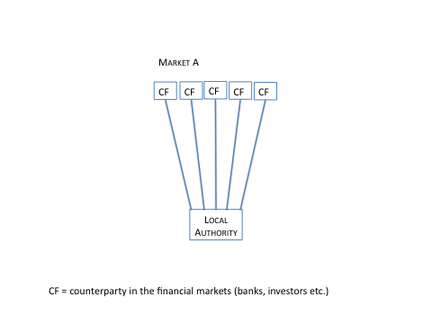These risks are mitigated by diversification in borrowing activities. Diversification means that you spread the borrowing to different markets, different financial instruments (bonds, private placements etc.) and have a number of loan programmes in place. The key to diversification is volume. The yearly borrowing size needs to be big enough that it enables you to spread the borrowing in the way described above. And it is not only a question of, for example, single bond issues in the different markets. You need to have a presence in each market that you use, so that you are properly recognised when a new bond issue is presented.

A single local authority, even the big, has limited possibilities of achieving diversification

Even very big local authorities do not have the amount of yearly borrowing to diversify its borrowing in the way an agency can. An agency has a far better possibility to diversify its funding than a single local authority, because of the size of its operations.

**Kommuninvest’s funding programme 2013 amounted to around, the equivalent to, £ 12,5 bn. Below is the diversification achieved 2009 – 2012:** 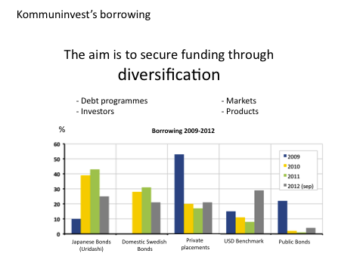

The possibility of diversification for a Municipal Bond Agency gives reason, not only for small local authorities, but also for larger cities to join such an entity.

The local government funding agencies of Scandinavia and the Netherlands had a steady access to funds in the market during the recent financial crisis. This was the result of their excellent ratings and the fact that the agencies had a real diversification of their borrowing. Another reason was the prudential way of conducting their operations. In the case of Sweden, Kommuninvest was able to help commercial banks by taking over their loan stock of local authorities.

Private entities that focused on lending to local authorities had in some cases severe problems. As examples, Dexia and the Austrian Kommunalkredit are noteworthy. In the case of Dexia, it led to a total dismantlement, which was caused by short-term borrowing and long term lending and investments in non-performing assets

**Higher creditworthiness for local authorities**

A Municipal Bond Agency needs to implement a system of monitoring the activities of local authorities. The reason for this is, of course, that the agency is directly dependent on the creditworthiness of their clients, just as any credit institution. However, the agency only has one category of client. This is both advantageous and disadvantageous. It is advantageous because it the agency can be very knowledgeable about the sector; its challenges and possibilities. It is disadvantageous because it does not spread credit risks to different sectors. This is why an agency has to be even stricter in their appraisal of loan applications than other institutions. Without a good credit rating and a good reputation among investors, an agency will not work. An agency owned and backed by a considerable number of creditworthy local authorities is destined to reach the best possible rating.

The reliance on the creditworthiness of the local authorities involved in the Agency’s activities also show why an agency would not give incentives to local authorities to take on excessive borrowing.

Let us look at the system for monitoring local authorities, used by Kommuninvest. The are two aspects to this:

1. A thorough investigation of the local authority creditworthiness before it gains membership in Kommuninvest.

2. A yearly assessment of the each member’s situation, in terms of the areas shown in the illustration:

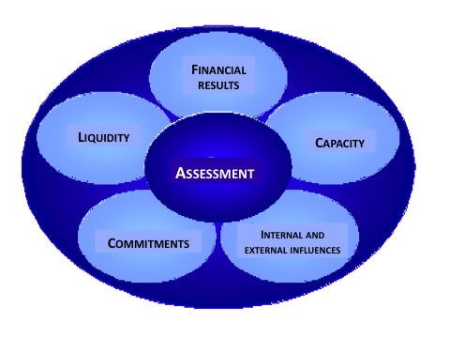

If the creditworthiness of a members has dropped substantially, there is a possibility that it was be expelled from the Agency.

It is very important that the prerequisites for entering into the Agency are strict and transparent. The Agency should always have the possibilities to refuse membership to local authorities with poor creditworthiness and also to exclude members with financial problems. In the case of Kommuninvest, existing members (local authorities) has the full power to set the criteria for joining the Agency, which assures that every new member has an acceptable creditworthiness. The fact that the members, with their knowledge about the sector, set the criteria also ensures that the quality of the credit quality assessment is excellent.

If high quality supervision of local authorities is combined with a reduction of borrowing costs and reduced risks in the funding activities (diversification), it gives very powerful incentives for councillors and financial directors to improve their authorities creditworthiness, in order to gain membership in the Agency. In my experience, peer pressure is much stronger than central government pressure.

Kommuninvest’s important role as gatekeeper, as well as giving incentives to improve creditworthiness, is recognised by the Swedish central government.

**A centre of expertise**

Local authorities main objectives are to provide basic services for their residents. These services could, for example, be water and sewage, solid waste disposal, transportation, education, care of the elderly and other types of local infrastructure. The focus of the local politician is to produce the “right” local services in the “right way”, and the evaluation of that is up to the voters in the local elections. The focus of the Financial director in a local authority is to organise proper accounting, to produce a budget and an annual report. The head of economic administration is generally not recruited for skills in financing, but more for extensive experience in budgeting and accounting. This leads normally to a situation where municipalities lack the necessary skills to handle external funding efficiently without excessive risk.

An agency has the possibility to employ financial experts to run these activities. However, this does not rule out the fact that an agency also needs people with a thorough understanding of the local government sector.

Both Kommuninvest and Agence France Locale have implemented a structure of governance that takes these matters into consideration. This is illustrated 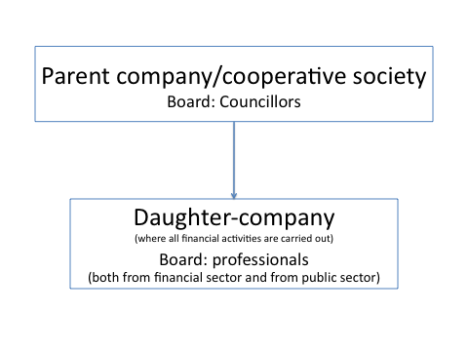below:

Kommuninvest has also taken on a role to support research in matters related to local government financing and related questions. Universities and other research institutions can once a year apply for grants to specific projects. The result of the supported research is communicated to Swedish local authorities.

**A centre for transfer of knowledge**

A very important role for an agency is to transfer knowledge to local authorities and Kommuninvest works actively in this regard. The transfer of knowledge takes place both in daily activities and at various events.

**At the level of the board of the cooperative society**

The board of Kommuninvest Cooperative Society, consisting of local politicians, receives a training program from Kommuninvest. Discussion within the board provides additional knowledge of the possibilities and conditions of the financial markets. The board is also an arena for exchange of knowledge on best market practices and solutions for the local authorities that the board members represent.

**Credit Research & Financial Committee**

The members of the Credit Research & Financial Committee are appointed by the Yearly General Meeting of the Cooperative Society. The Committee is responsible for monitoring the financial status of member municipalities as well as developments in the municipal sector as a whole. It is also tasked by the Society’s Board to process new membership applications.

The committee is made up of financial directors in local authorities that are members of Kommuninvest. The Committee’s instructions state that it shall represent different parts of Sweden, have experience from different types of municipalities and knowledge of funding operations.

The Committee’s Tasks:

* Screen municipalities and county councils that apply for membership of Kommuninvest Cooperative Society, and give an opinion on the applications.
* Review each member of Kommuninvest Cooperative Society at least twice a year.
* Follow economic and financial developments in the municipal sector.
* Develop the analysis model used to review municipalities and county councils.
* Consider issues of primary economic and financial importance to the municipal sector.
* Deal with issues regarding future assessments relating to the financial position of the municipal sector, and national economic developments.
* Assist the Society’s Board in preparing statements on specially referred issues.
* Otherwise performing tasks set by the Society’s Board.

This Committee is an important instrument for the activities of Kommuninvest, but also a way to spread knowledge and awareness of questions related to financial markets and instruments, risks and creditworthiness.

**Seminars**

Annualy, Kommuninvest arranges a number of seminars on subjects related to its activities. Both local politicians and officials attend these seminars.

Eight financial seminars were arranged in different parts of Sweden during the autumn of 2013.

Kommuninvest are to arrange 18 Member Consultations in 2014. These are conferences, in all parts of Sweden, where the overall strategy for Kommuninvest, as well as current issues, are discussed.

The General Meeting is also organised as a conference to which speakers from central government and other organisations are invited.

**Consultancy**

In the first part of Kommuninvest’s history, consultancy was a part of its activities. The agency carried out loan stock reviews, and consulted on routines and procedures.

**General communication - publications**

Communication is one of the most important areas for an agency. One could look at an agency as the interpreter between the international financial markets and the local government sector. It is obvious that great efforts have to be applied to inform investors of the Agency, its clients and its activities. An extensive programme of road shows has to be implemented. But, it is also crucial to inform local authorities and to teach them about financial markets, financial instruments and, maybe above all, risk management.

Kommuninvest issues the following publications



**Dialog**; A magazine with 4 – 5 issues a year aimed at councillors and financial directors, as well as others interested in public finance



**Perspektiv**; three issues a year with in-depth articles about financial questions, aimed at Financial Directors

**Veckobrev**; weekly newsletter distributed as e-mail. Include a market up-date and information of rates, currencies etc. Aimed at Financial Directors.



Graphs & charts updated every month



Examples for appropriate wording of council decisions related to finance

**Regarding competition**

Financial institutions owned by the public sector are viewed with suspicion from the point of view of a free competition. EU-directives set an extensive and detailed framework for keeping the public sector from distorting free markets. It is therefore important to consider whether an agency distorts competition.

Firstly, it is essential to discuss the specific regulations of an agency. Experience has shown that the most cost-efficient funding for local authorities occurs when the agency does not have a monopoly and local authorities are free to borrow from any credit supplier in the market. It is essential that all borrowing should be open to fair and transparent competitive bidding. An agency should not be given any specific advantages or privileges such as exemption from taxes, although it can be argued that local government is a part of the country’s government that indeed levies taxation. It is an important conclusion that the Agency should, as far as possible, adapt to market practices.

Some argue that a publicly owned financial institution, with or without a guarantee from its owners, distorts the free markets. However, this is a weak argument since the only purpose of a municipal bonds agency s to service its members, local authorities, with financing solutions. An agency does not lend in an open market. It does not lend money to any third party in the competitive sector.

An agency’s role is to create advantages for the involved groups, which is identical to the underlying principle behind the whole cooperative movement. In its funding operations an agency works in full competition with other market players and it is only natural that the stakeholders of a funding entity would explore every possible way (such as guarantees) to lower the costs of funding. In lending operations, the Agency must be cost efficient in full competition with banks and other parties in the financial markets.

In conclusion, if a Municipal Bond Agency is operating in a free market competition is boosted. The absence of an Agency often leads to markets characterised by oligopoly consisting of a few suppliers of credit.

# Appendix 3 – Outstanding amounts of Local Authority Borrowing and Investments

# 

Source: https://www.gov.uk/government/statistical-data-sets/live-tables-on-local-government-finance

# Appendix 4 – Additional Market Background (1 of 6)

# The Sterling Bond Market: Underlying Rates and Spreads

**Gilts near historic lows – recent tightening of credit spreads for high quality issuers**

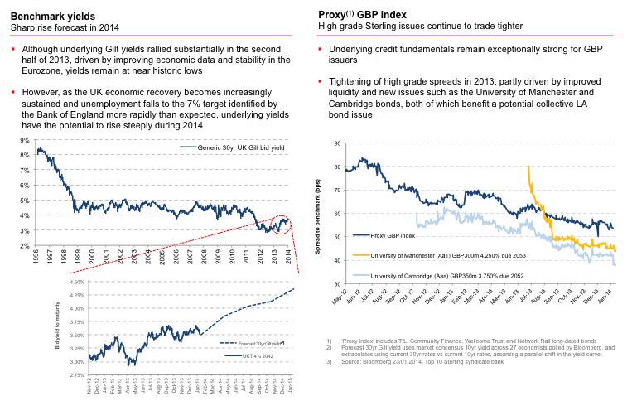

# Appendix 4 – Additional Market Background (2 of 6)

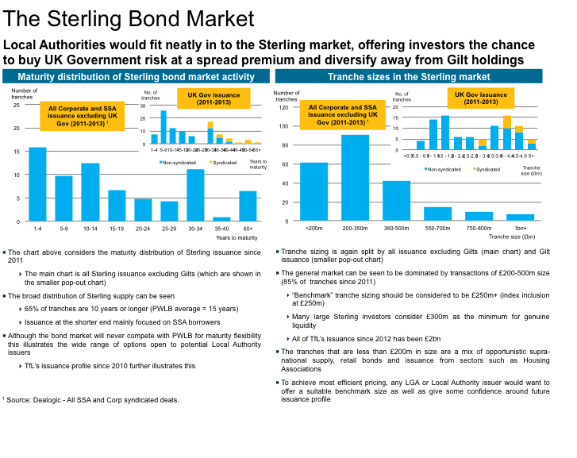

# Appendix 4 – Additional Market Background (3 of 6)

# Top 30 issuers with outstanding Sterling Debt

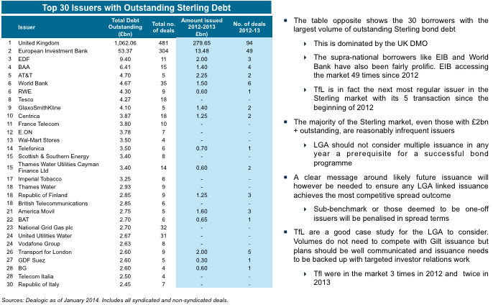

# Appendix 4 – Additional Market Background (4 of 6)

# Detailed Sterling Comparables

**Only highest quality Sterling Bonds should be used as comparatives**

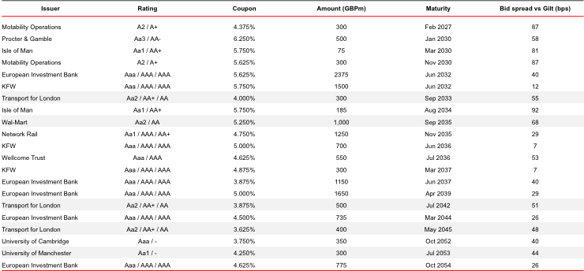

Source: Top 10 Sterling syndicate bank, Jan 2014

# Appendix 4 – Additional Market Background (5 of 6)

# Assessing relative value for local authority and similar borrowers

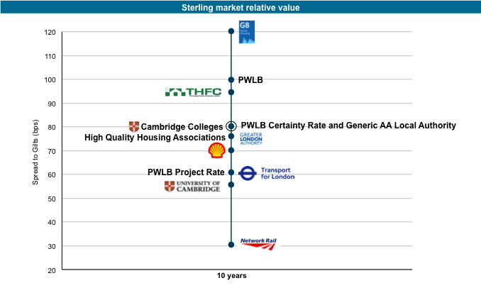

Source: Top 10 Sterling syndicate bank, Jan 2014

# Appendix 4 – Additional Market Background (6 of 6)

# Secondary performance overview of comparable bonds since July 2012

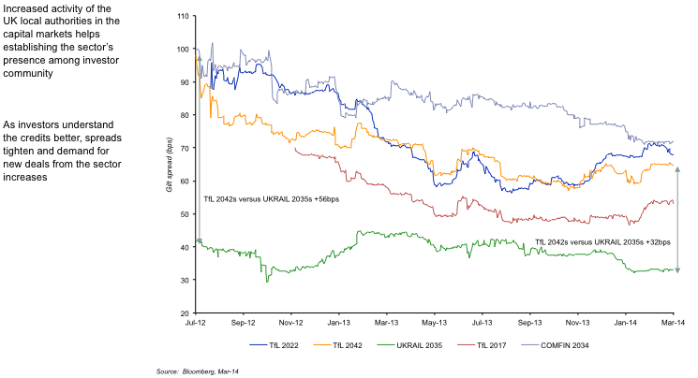

Source: Top 10 Sterling syndicate bank

# Appendix 5: Biographies of the Authors

**Aidan Brady – Lead Advisor**

Aidan, a partner in Danela Ventures Partners Limited, is a seasoned executive, with over twenty years financial services experience.

Aidan's career in financial services began in 1992, when he joined Merrill Lynch. He subsequently joined Bankers Trust, which was acquired by Deutsche Bank.

At Deutsche Bank, Aidan held a number of senior roles, including Chief Executive Officer of DB UK Bank, Chief Operating Officer for Deutsche Bank UK, Chief Administrative Officer for the Legal, Risk and Capital division, Chair of the Global Cost Committee, Chair of the UK Operating Committee, Member of the UK Regional Governance Board, and deputy member of the Group’s Global Investment Committee. He has also worked for UBS in an interim COO capacity.

Prior to his career in the City, Aidan, a Chartered Accountant by background, worked for major accountancy firms in Ireland, London and Hong Kong

Aidan co-founded of Danela Ventures Partners Limited, which focuses on financial services innovation and is currently building a new UK corporate banking platform.

**Lars M Andersson – Strategic Adviser**

Lars initiated the creation of [Kommuninvest, the Swedish Local Government Funding Agency](http://www.maproductions.se/?page_id=502), in 1986. Mr Andersson became the agency’s first president and developed its operations until 2001.

During the last 20 years, he has worked as an advisor to local authorities in many parts of the world. Among other projects, Lars has been an advisor, during the last five years, to the French Local Government Associations in the project that led to the creation of Agence France Locale in October 2013.

Lars is now a member of the Supervisory Board of Agence France Locale and chairman of the Strategy Committee within the Board. Mr Andersson is also chairman of Kommuninvest’s Committee for its Research Fund.

In 2012 Lars, together with Sören Häggroth, published the book Kommunala vägval *(Municipalities at the Crossroads)* and is currently writing a second book on the future challenges for local authorities.

**Francis Breedon – Strategic Adviser**

Francis is Professor of Economics and Finance at Queen Mary, University of London, having previously been a Senior Lecturer in Finance at Imperial College Business School

Francis was previously Global Head of Currency Research at Lehman Brothers and a Senior Researcher / Manager at the Bank of England. He started his career as a Research Officer and the Centre for Economic Forecasting at the London Business School

Francis has published numerous articles and books, including:

Articles

“The Financial Market Impact of UK Quantitative Easing (with J. Chadha and A. Waters) Oxford Review of Economic Policy, Winter 2012

“A Variance Decomposition of Index-Linked Bond Returns” Economics Letters, July 2012

“Differences in Beliefs and Currency Risk Premia” (with A. Beber and A. Buraschi) Journal of Financial Economics, December 2010

“Investigating Excess Returns from Nominal Bonds” (with J. Chadha). Oxford Bulletin of Economics and Statistics, February 2003

“Bidding and Information: Evidence from UK Gilt-Edged Auctions” (With J. Ganley). Economic Journal, October 2000

“The Valuation of sub-underwriting agreements for UK rights issues” (with I. Twinn) Bank of England Quarterly Bulletin, 1996

“Bond prices and market expectations of inflation” Bank of England Quarterly Bulletin, 1995

Books

“Macroeconomics: Understanding the Global Economy” (with D. Miles and A. Scott) Wiley, 2012

“Estimating and Interpreting the Yield Curve” (with N. Anderson, M. Deacon, A. Derry and G. Murphy). J. Wiley 1996

# Glossary

**Arranger:** Usually an investment bank, who manages the sale of *bonds* or other securities on behalf of an issuer, or the establishment of a programme such as a *Medium Term Note* programme. Often two arrangers are appointed for large, significant or complicated issues.

**Basis Point:** One hundredth of 1% i.e. 0.01%; often abbreviated to “bps”.

**Benchmark Size:** A *bond* issue large enough to provide sufficient *liquidity* that the pricing can vary in line with the market’s assessment of the issuer’s *creditworthiness*. In the UK, this is typically £250 million to £300 million. Commonly such issues are also large enough to be included in the bond indices, such as iBoxx, against which bond investors assess their performance.

**Bond:** An interest bearing security, usually with a fixed *maturity*. Bonds are analogous to a loan, but with the loan divided up into small pieces. Purchasers buy the bond in order to receive the interest or *coupon* during its lifetime and to be repaid the principal when it matures. A bond’s “price” usually refers to the cost of purchasing the bond, but in relation to new issues, common practice is to describe the price in terms of the “*spread*”.

**Capital Requirements Directive IV or “CRD IV”:** The EU Directive that implements enhanced capital requirements for banks and financial institutions. The Directive incorporates the supranational Basel III rules that set global capital requirements for banks.

**Certainty Rate:** The interest rate at which the PWLB lends to local authorities who disclose to the PWLB certain information regarding their borrowing and capital investment plans. The certainty rate is 0.8% over Gilts and a reduction of 0.2% from the standard PWLB interest rate.

**Coupon:** The interest rate payable on a bond.

**Commercial Paper:** *Bonds* with a *maturity* of less than one year when issued.

**Commercial Paper Programme:** A vehicle that enables an *issuer* to sell *commercial paper* on a frequent basis without needing to issue a prospectus and obtain any necessary regulatory approval for every issue of the paper. Such programmes established in Europe for sale to UK and European investors are often described as Euro Commercial Paper programmes or “ECP”. ECP programmes typically allow *commercial paper* to be issued in different currencies including Sterling, the EURO and US dollar.

**Cost of Capital:** The interest and/or dividend rate that an entity must pay investors i.e. its cost of funds.

**Credit Rating Agency:** Independent organisation that assesses the creditworthiness of issuers to determine a “credit rating”. In relation to bonds, the term usually refers to Standard & Poor’s, Moody’s and Fitch, each of which has its own system of credit ratings and assessing *creditworthiness*.

**Credit Structure:** The legal and financial structure of the Agency and its bond programmes.

**Creditworthiness:** The likelihood that an entity will pay its debts in full and on time.

**Debt Management Office:** Usually abbreviated to “DMO”, an executive agency of the Treasury that manages the debt and cash of the Government.

**Default:** Usually refers to a failure by an entity to make a debt repayment on time. A technical default can also occur when the terms or conditions of a bond, loan or other agreement are broken even though the debt is still being repaid on time.

**Diversification:** In relation to the Agency, this relates to the number, type and geographic spread of the local authorities borrowing via the Agency. Ideally the more authorities across the country, covering all types of local authority that borrow, the greater the diversification. Typically, a higher level of diversification is considered better.

**Early Redemption**: Where a loan or *bond* is repaid before its *maturity*. In the case of a bond, the bond is typically bought back and cancelled. In the case of a loan, the principal is repaid to the lender together with any fee or penalty due. This is referred to as “premature repayment” by the *PWLB*.

**ECP:** See *Commercial Paper Programme.*

**EMTN:** See *Medium Term Notes*.

**Equity:** The funds available to shareholders if all other liabilities have been met. This is typically the shareholders’ initial investment together with any profits retained by the company.

**Execution Risk:** The risk that a transaction or business plan will either not be successful, or achieve outcomes that are less than those expected e.g. a *spread* that is worse than anticipated, or market share less than expected.

**Face Value:** In relation to bonds, refers to the principal or redemption value of a bond. This is the amount that an issuer pays to investors when the bond matures.

**Financial Conduct Authority:** Often referred to as the “FCA”, the Financial Conduct Authority is responsible for the regulation of financial services firms and ensuring the integrity of the UK’s financial markets. The FCA focuses on the conduct of both retail and wholesale financial services firms, together with their staff.

**Financial Instrument:** Describes any asset or contract that gives rise to a financial asset for one entity and a financial liability for another (including *equity*). Financial markets tends to use the term to cover any asset or contract that can be easily traded such as bonds, shares, foreign currencies and derivatives. Accountants tend to use a broader definition that covers assets and liabilities that are not easily traded.

**General Power of Competence:** Introduced under Chapter 1 of the Localism Act 2011, the power permits “a local authority has power to do anything that individuals generally may do” unless it is proscribed by other legislation and regulations e.g. it does not permit the introduction of new taxes.

**Gilts:** *Bonds* issued by the UK Government with a *maturity* when issued greater than one year.

**Hold back:** A portion of a loan taken out by a borrower, but not paid over by the lender.

**Investor Relations:** Maintaining effective relationships and good communication with current and potential investors.

**Issuer:** The legal entity that issues *bonds* or other security.

**Joint and Several Guarantee:** A guarantee under which one of the guarantors can be held liable for the whole of the guaranteed debt, despite being responsible for only part of that debt; a creditor can pursue any or all of the guarantors in the event of default.

**Liquidity:** In relation to the Agency (also banks and other entities) means the availability of cash to meet payments due. In terms of the financial markets, it refers to the ready availability of securities for sale and purchase; typically the greater the liquidity the better.

**LOBO:** “Lender Option, Borrower Option” loan. The lender has the option to change the interest rate at regular intervals, usually between six months and five years, and the borrower has the option to reject the change and to repay the loan.

**Market Making:** Where an investment bank agrees to offer to sell and bid to buy securities in the secondary market. Typically, all members of a *syndicate* placing *bonds* are expected to be market makers.

**Maturity:** Describes when a loan or *bond* has to be repaid. Depending on context, the term can relate to a specific date e.g. 31 March 2015 or a period of time e.g. 10 years.

**Medium Term Notes:** *Bonds* with a *maturity* of more than one year and typically less than thirty years, although bonds with maturities of up to 100 years have been known. The bonds are issued via a programme that enables an issuer to sell bonds on a frequent basis without needing to issue a prospectus and obtain any necessary regulatory approval for every issue of the bonds. Such programmes established in Europe for sale to UK and European investors are often described as Euro Medium Term Note programmes or “EMTN” programmes. EMTN programmes typically allow bonds to be issued in different currencies and both secured and unsecured bonds. The key benefits of a programme are flexibility and cost effectiveness.

**New Issue Premium:** New issuers of bonds typically pay a slightly higher *coupon* to reflect that they are not as well known in the market as existing issuers and that their performance is unknown.

**Par Yield:** See *yield*.

**Present Value:** Is the value of a future sum of money in today’s terms. £100 today is always worth more than £100 in the future because £100 today can be invested to earn interest (inflation also reduces the purchasing power of money over time). The process of calculating present value is known as “discounting”.

**Primary Market:** The sale of new *bonds*, shares and other financial instruments to investors, typically via the *syndicate*.

**Prudential Code:** The Prudential Code is a professional code of practice to support local authorities in taking capital investment decisions including the funding of capital investment. The Code helps force local authorities to consider whether borrowing is affordable and financially sustainable. Local Authorities are required by regulation to have regard to the Prudential Code.

**Prudential Regulation Authority:** The Prudential Regulation Authority or “PRA” is responsible for the prudential regulation and supervision of banks, building societies, credit unions, insurers and major investment firms

**Public Works Loan Board:** Usually abbreviated to “PWLB”, part of the *Debt Management Office* and lends money to local government and other prescribed bodies on behalf of the Government.

**Repurchase Agreement:** Short for “sale and repurchase agreement” and usually abbreviated to “repo”, provides means for a bank or other entity to borrow money for short periods, usually to provide *liquidity*. A repo involves the sale of a security on the basis it is bought back on an agreed date.

**Right of Recourse:** In the context of the Outline Business Case, the right of one or more local authorities to require one or more other local authorities to reimburse them for sums paid out under the *Joint and Several Guarantee* or to pass some of that liability on in the event of a claim under the guarantee.

**Risk Capital:** The long term funds invested in an entity that are particularly at risk in the event of insolvency or bankruptcy. The terms always includes *equity*, but includes *subordinated debt* if it exists.

**Secondary Market:** The financial market in which previously issued *bonds*, shares and other financial markets are bought and sold, usually via a stock exchange or similar.

**Section 151 Officer:** The chief financial officer of a local authority. Section 151 of the Local Government Act 1972 requires every local authority to make arrangements for the proper administration of its financial affairs and requires one officer to be nominated to take responsibility for the administration of those affairs.

**Sovereign:** In the context of the Outline Business Case, the UK Government.

**Spread:** Commonly used to describe the difference in yield between two financial instruments, usually of the same (or very similar) maturities. Typically, one instrument is a “reference security” such as government *bond*, or a “reference rate” such as a commonly used interest rate e.g. the London Interbank Offered Rate “LIBOR”. It is usually expressed in terms of *basis points* e.g. “a 45 basis point spread to Gilts”. Often used interchangeably with “margin”.

**Subordinated Debt:** Debt that has a lower priority for repayment than other debts in the event of insolvency or bankruptcy. In relation to the Agency, the subordinated debt will rank lower than the *bonds*. Subordinated debt has a higher priority than *equity*.

**Syndicate:** The group of banks that will be appointed to sell the Agency’s *bonds* to investors in the *primary market*.

**Tap or Tap Issue:** In relation to the Outline Business Case, is when an issuer sells new *bonds* that form part of a past issue. The additional bonds are issued at the original *face value*, *maturity* and *coupon*, but sold at the current market price for the issue. For example, a 25-year £250 million issue made 2 years ago could be increased by £50 million, but the additional bonds would mature in 23 years’ time. Tap issues are common when an issuer has a *Medium Term Note* programme. The financial markets sometimes use “tap” to describe any *primary market* issue e.g. a company “tapped the markets with a £500 million share issue”.

**Trade:** In relation to the Outline Business Case, describes the yield on the Agency’s *bonds* at a given point in time. A “trade” in financial markets is the buying and selling of a financial instrument.

**Treasury Bills:** *Bonds* issued by the UK Government with a maturity when issued of less than one year, usually three months. (The US Government also issues its own bills, usually referred to as T-Bills.)

**UK Listing Authority:** Usually abbreviated to “UKLA”, is a division of the *Financial Conduct Authority* and oversees the issuers of securities. In particular, it focuses on the rules that govern the listing of securities on the UK’s stock exchanges, known as the “Listing Rules”.

**Yield:** The income from a security expressed as a proportion of its current price e.g. a *bond* bought for £100 with a coupon of £5 has a yield of 5%. Par yield is the *coupon* earned when a bond is priced at par, par being the face value of the bond.

**Yield Curve:** The different *yields* returned on otherwise identical bonds with different maturities e.g. *Gilts* with a *maturity* of one year will normally have a different yield to those with a maturity of 10 years. Normally, yields rise with maturity – the “normal” yield curve. When interest rates are expected to fall, yields fall with maturity – the inverse yield curve. Currently, interest rates are at historically low levels, but expected to rise in the future causing a “positive” or “rising” yield curve where yields on medium and long terms bonds are much greater than for short term bonds.

1. On 7th March 2014, TfL reportedly issued a 50-year, £370 million bond at 55 basis points over the reference Gilt.
2. See for example “Local Authority Borrowing” H Page 1985
3. 3 Source: CLG statistical datasets <https://www.gov.uk/government/statistical-data-sets/live-tables-on-local-government-finance>
4. Source: CLG, derived from statutory data returns supplied by local authorities.
5. Source: PWLB monthly loan reports.
6. Temporary Accommodation falls to the General Fund and not the HRA.
7. Source: CIPFA Capital and Treasury Statistics, supplied by CIPFA’s Statistical Information Service.
8. Source: CIPFA Capital and Treasury Statistics, supplied by CIPFA’s Statistical Information Service.
9. Source: CIPFA Capital and Treasury Statistics, supplied by CIPFA’s Statistical Information Service. Does not include Scottish authorities because CIPFA does not cover Scotland.
10. Source: ONS population estimated and projections.
11. Source: CLG statistics
12. Source: PWLB published rates
13. On 7the March 2014, TfL reportedly issued a 50 year, £370 million bond at 55 basis point over the reference Gilt.